5/17/02

To: NDA 20838, SE 4-015
From: Stephen Fredd, HFD-110
Subject: Medical Review

BACKGROUND
On 9/27/2001 AstraZeneca submitted a supplement to their approved NDA for Candesartan cilexetil to add statements in the Clinical Trials, Clinical Pharmacology and Overdose sections of the labeling. They propose incorporating the results of studies 230 and 231 (the CLAIM studies) to provide comparative efficacy information of Candesartan to losartan in the Clinical Trials section. The Clinical Pharmacology section would be amended to include new data on PK in hepatically impaired individuals with a recommendation for consideration of a lower starting dose. The Overdose section would be revised to delete the case report of the one overdose patient currently described, and include the “most clinically useful information” derived from a review of all overdose cases received between October 1996 and October 2000. Volumes 1.1, 1.4, 1.5-1.85 and electronic submissions of the case report tabulations and case report forms were provided for the medical review.

COMPARATIVE EFFICACY
The CANDLE study (protocol 175) and the Claim studies (protocols 230 and 231) provide the basis for the sponsor’s claim that “Candesartan cilexetil initiated at 16 mg once-daily and forced-titrated at 2 weeks to 32 mg once-daily was statistically significantly more effective than losartan 50 mg once-daily forced-titrated at 2 weeks to 100 mg once-daily in reducing systolic and diastolic blood pressure at 8 weeks.”
The following exposition uses the sponsor’s analyses and displays of the results of the studies. A separate statistical review by Dr. James Hung provides independent analyses of the SAS datasets submitted, and verifies the sponsor’s numbers.

The CANDLE Study
This was a randomized, parallel 8 week study of Candesartan versus losartan in 232 adult hypertensive patients. The design of the study was:
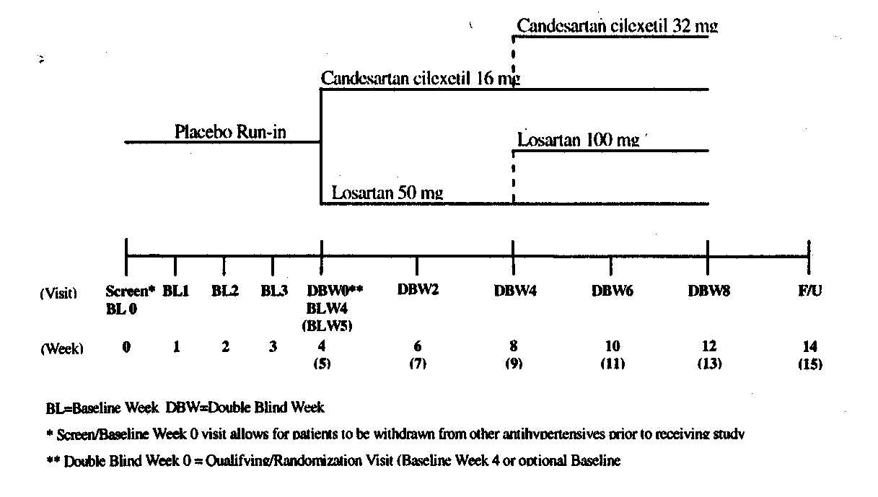

332 male or female patients, age 18-80 years, with essential hypertension i.e. Sitting diastolic blood pressure (Sitting DBP) of 95 mmHg to 114 mmHg on two visits were randomized to 16 mg of Candesartan or losartan 50 mg once-daily. Patients with orthostatic hypotension, history of MI or stroke within 6 months, liver or renal disease were excluded. If after 4 weeks of therapy the Sitting DBP was 90 mmHg or more, the patient was uptitrated in their assigned group to 32 mg of Candesartan or 100 mg of losartan once-daily.
The primary question was whether a difference in antihypertensive efficacy between treatments could be detected by comparing the difference in trough Sitting DBP from baseline through 8 weeks for each group. Secondary prespecified endpoints were change from baseline through week 8 of the double blind period for trough Sitting systolic blood pressure (SSBP), standing DBP, standing SBP, and like analyses of peak BP. The ITT analysis was primary, and per protocol analyses were to be done secondarily.
The losartan was obtained commercially and encapsulated for blinding to a placebo capsule. Candesartan was provided as a tablet or matching placebo. Each patient was given one active drug and on placebo. There was no all-placebo arm. The encapsulated losartan was considered equivalent to commercial losartan by virtue of dissolution testing.

The schedule of procedures was:
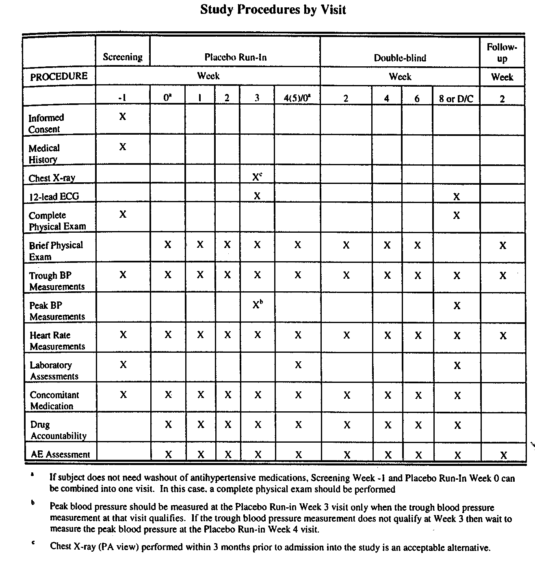

460 patients were screened for the study. 332 were randomized to either Candesartan (n=162) or losartan (n=170). 309 patients completed the 8 week double-blind portion of the study (Candesartan n=155, losartan n=154).
Treatment compliance was measured by determining the number of capsules and tablets returned to the study coordinator from the treatment packs dispensed. Mean compliance during the 8 week double-blind study was calculated at 100.9% and 100.3% for Candesartan and losartan respectively.
The sample size of 165 patients per group was estimated to be adequate to provide 95% power to detect a true difference in mean change from baseline in trough Sitting DBP of

3 mmHg. Assuming a standard deviation of 7.5 mmHg, statistical significance on a two-tailed test with an α=0.05 could be determined. Trough was defined as 24±3 hours post dosing. Peak was defined as 6.5±2.5 hours post-dosing.

Baseline characteristics of those randomized was:
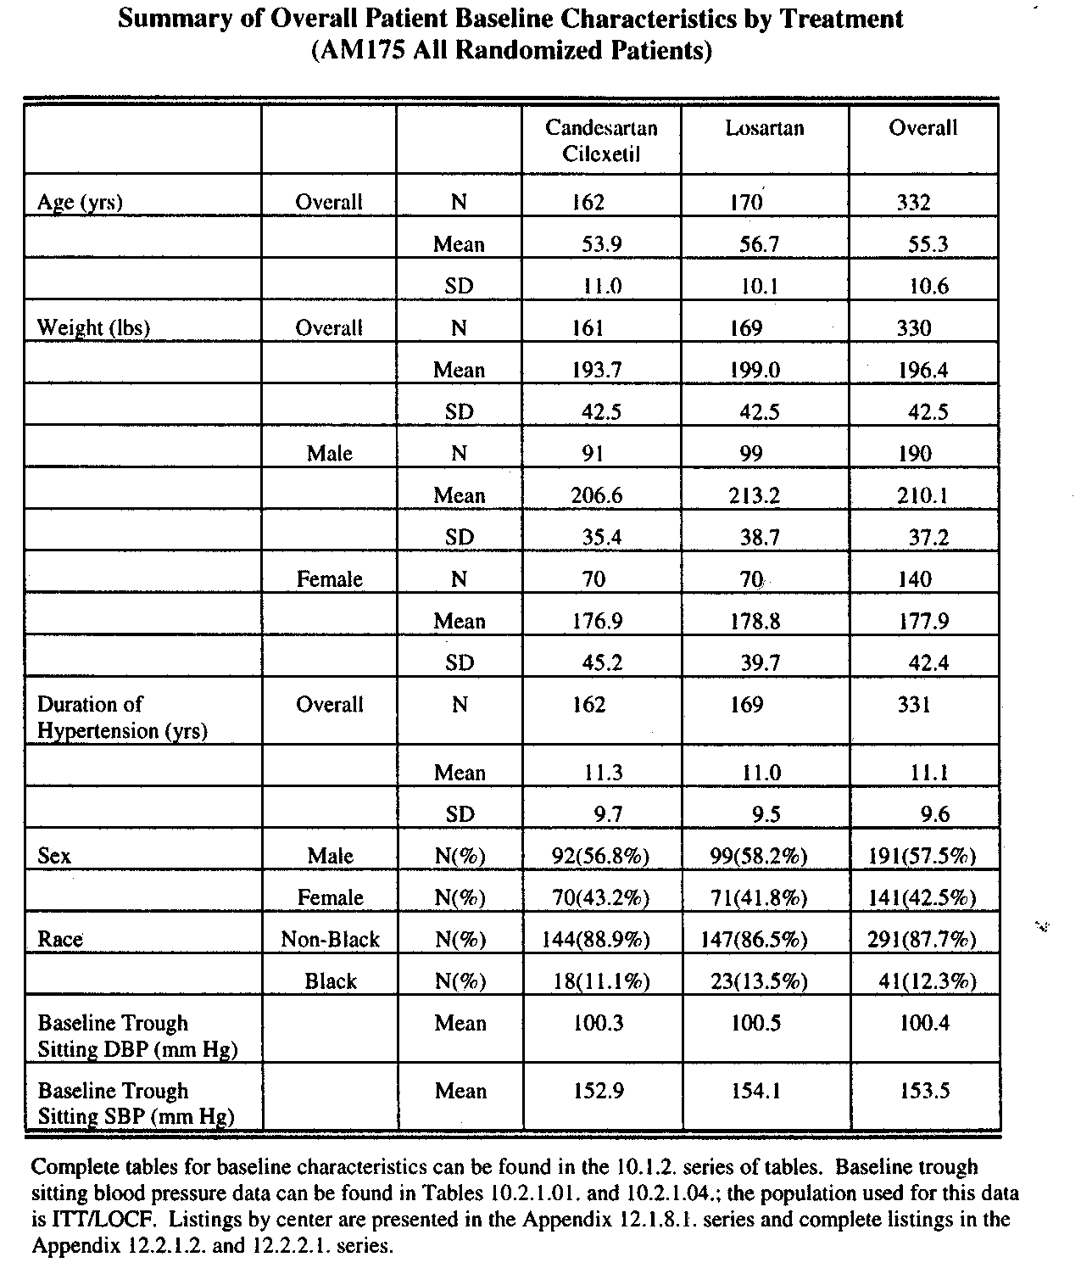

Efficacy Results
The change from baseline in DBP and SBP, trough and peak, Sitting and standing were provided as follows:

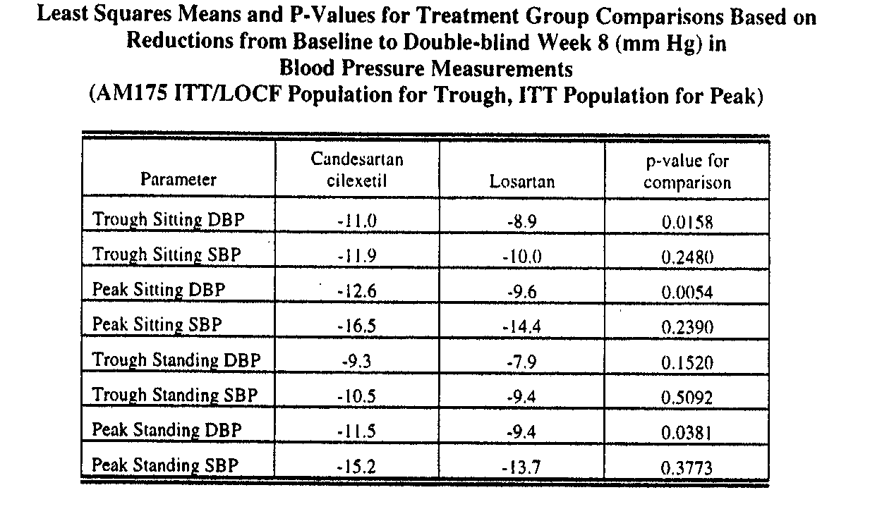
Subgroup analyses of the primary endpoint results were:
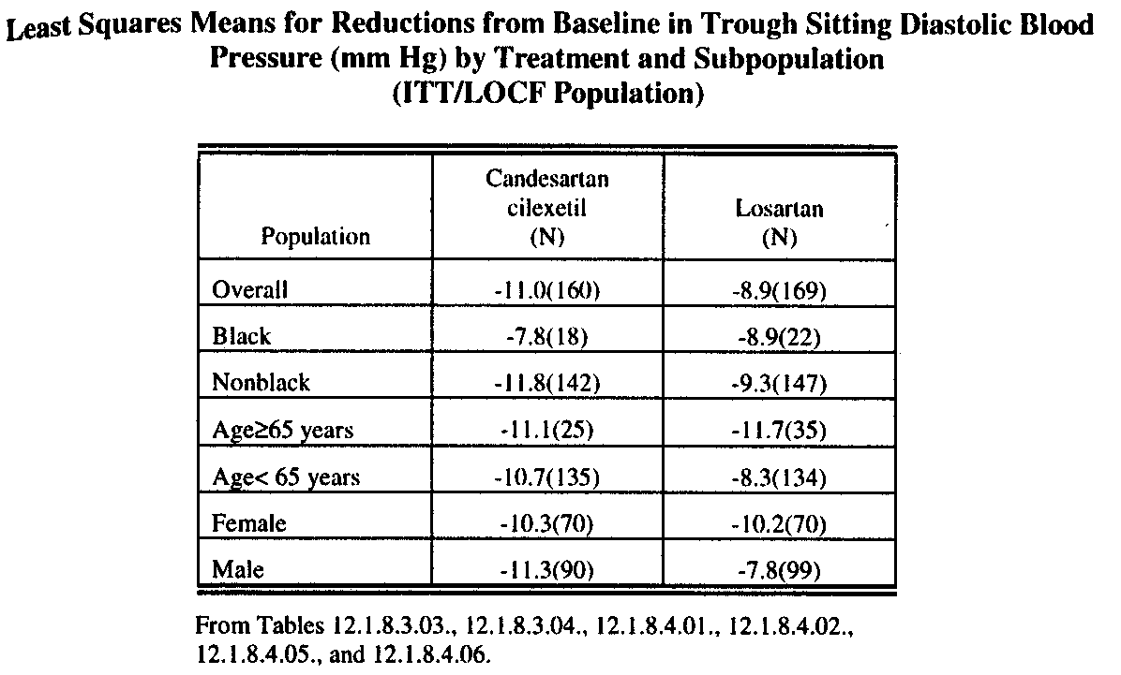

The primary endpoint of change in trough Sitting DBP from baseline through week 8 of the double-blind period for each treatment was displayed in two-week increments as below:
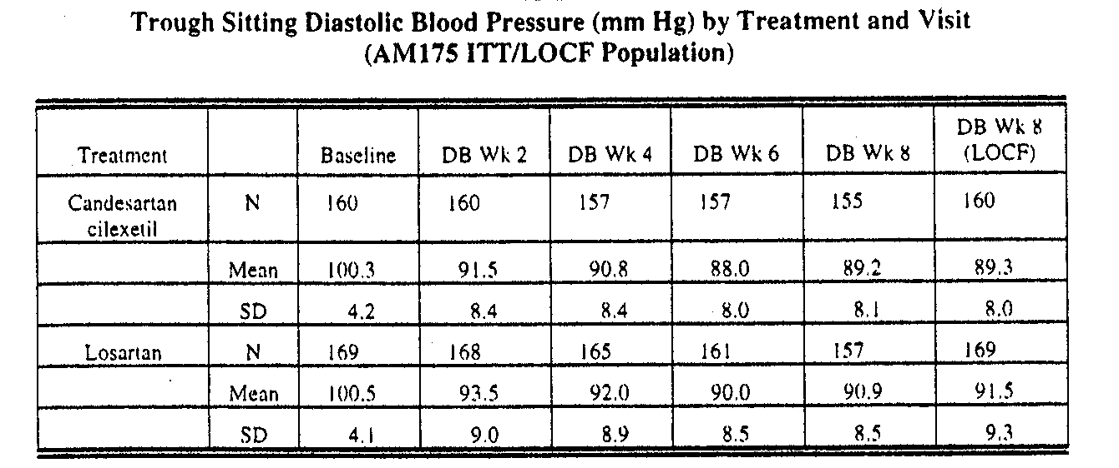
At 2 weeks the Sitting DBP change from baseline for Candesartan was 8.8 mmHg. From 2 weeks through 8 weeks the change was 2.3 mmHG. For losartan those results were 7 mmHg and 2.6 mmHg. Clearly the major antihypertensive effect occurred in the first two weeks, before any patient was uptitrated.
From baseline through week 2 patients were on either Candesartan 16 mg or losartan 50 mg once-daily. Those not responding (Sitting DBP<90 mmHg) were uptitrated. Results for those uptitrated and those not-uptitrated were:
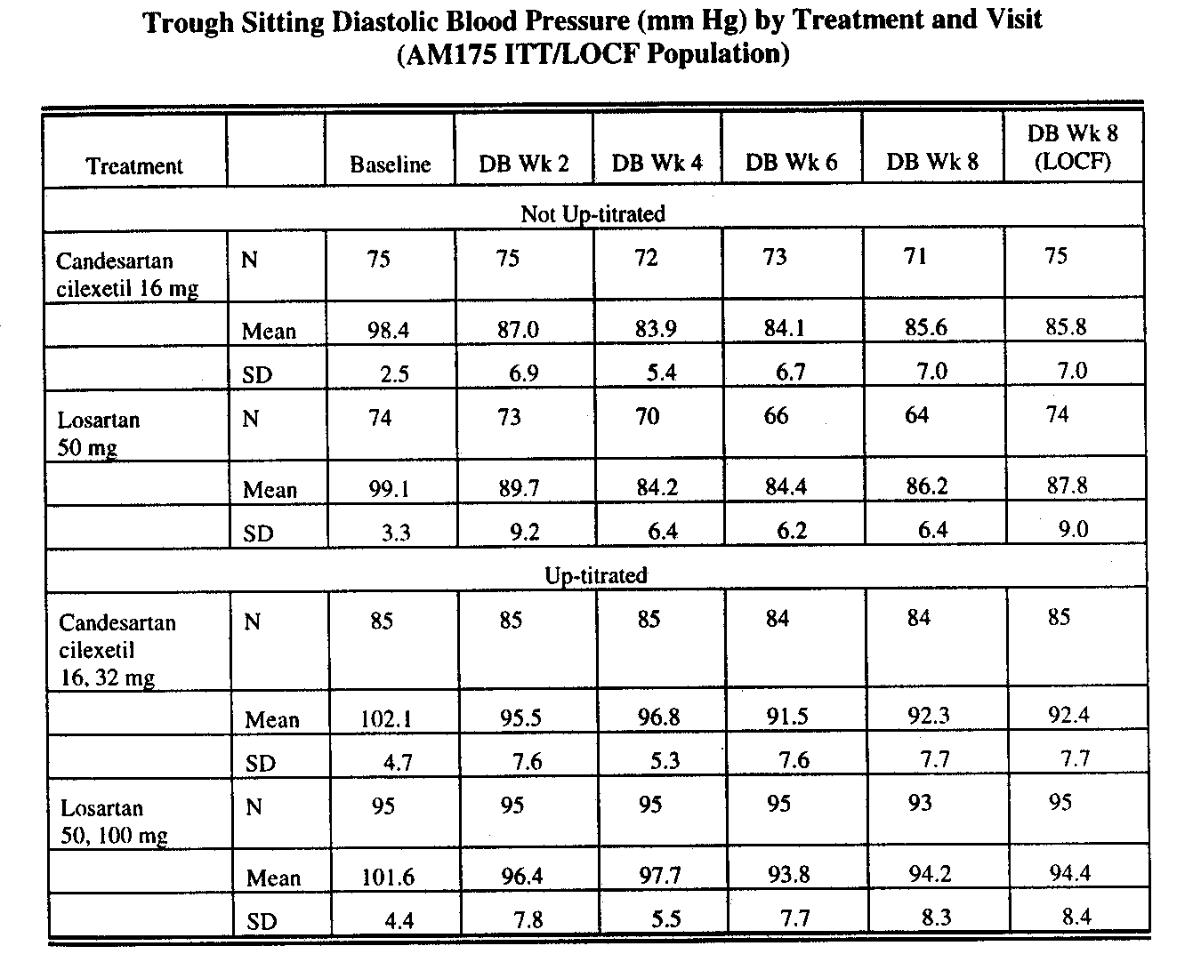

Approximately 54% of the Candesartan patients and 58% of the losartan patients were uptitrated.
For the not-uptitrated group, the Sitting DBP change from baseline at 2 weeks for the Candesartan group was 11.4 mmHg, and 1.2 mmHg from 2 weeks through 8 weeks (LOCF). Those results for the losartan patients were 9.4 and 1.9 mmHg.
For the up-titrated group, the Candesartan result at 2 weeks was 6.6 mmHg, and for 2 through 8 weeks (LOCF) 3.1 mmHg. For losartan the results were 5.2 and 2.0 mmHg.

Safety Results
No deaths occurred in this study.
Patients who withdrew for adverse events were detailed as follows:

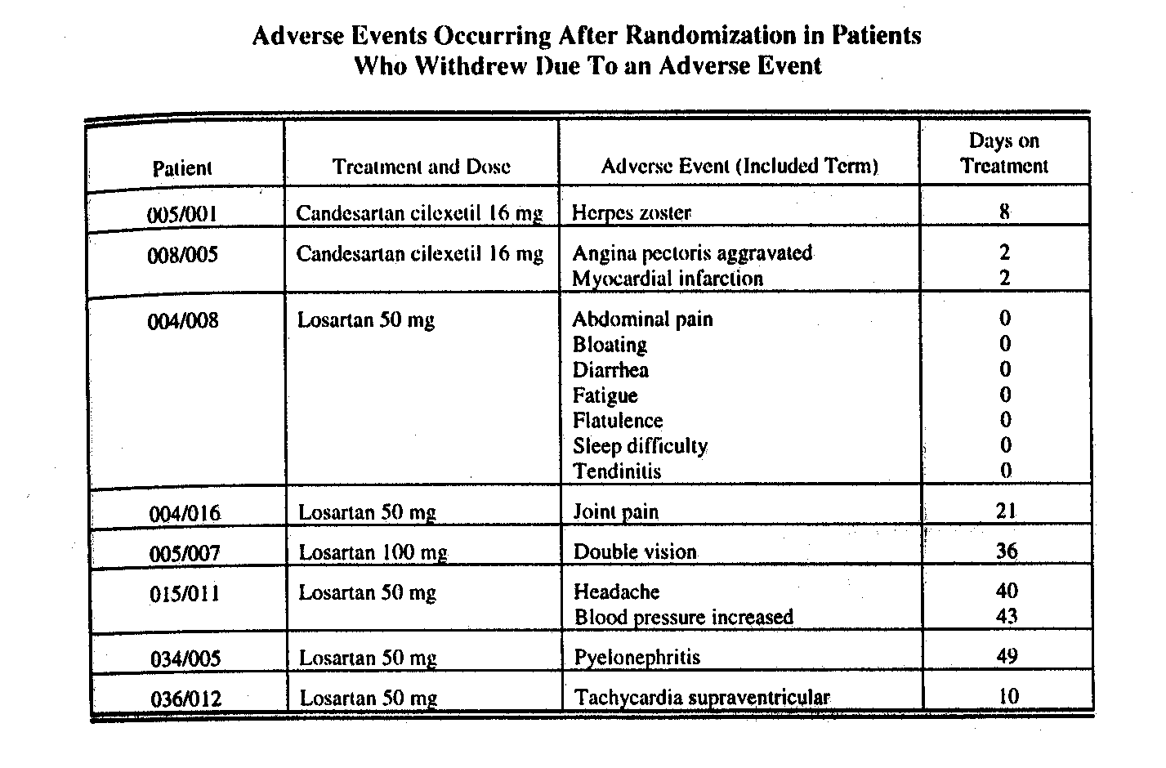

Other serious adverse events were:
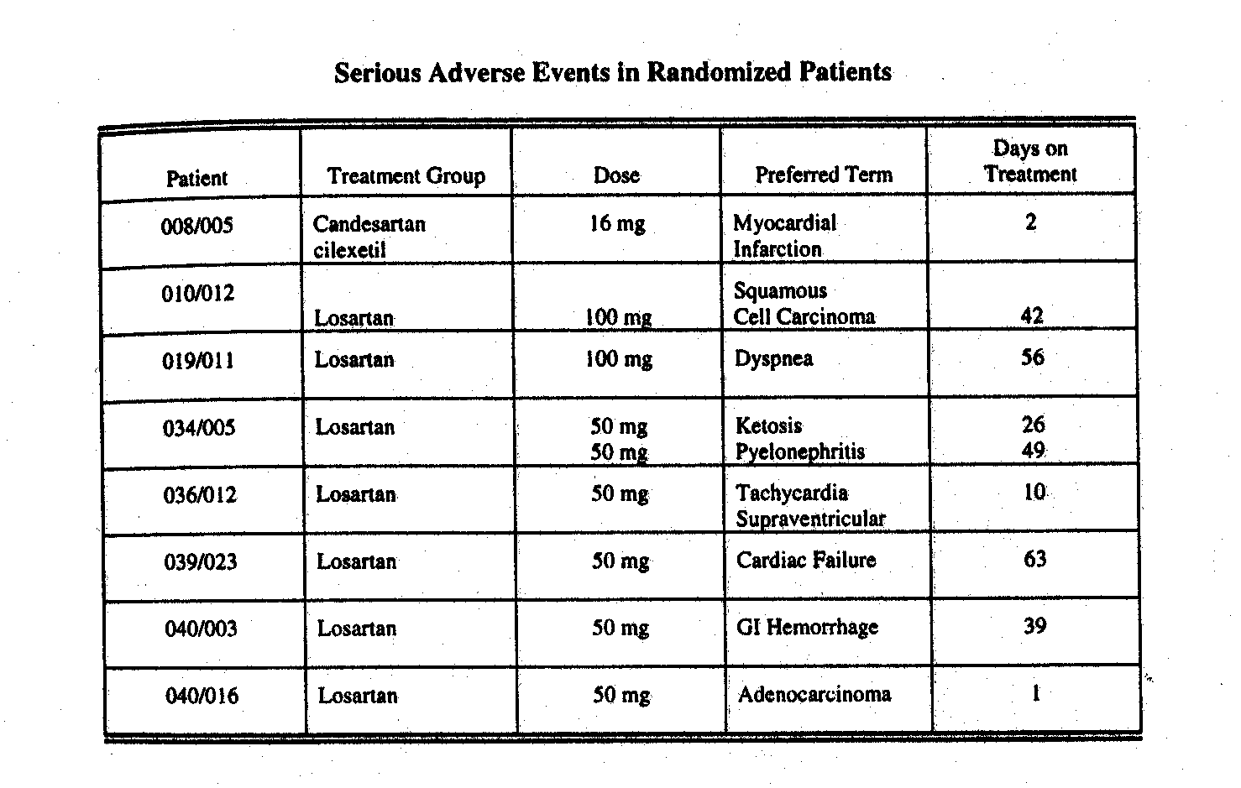

The CANDLE study will be discussed with the CLAIM studies.

B. The CLAIM Studies (Studies 230 and 231)

Studies 230 and 231 were randomized studies comparing Candesartan to losartan for antihypertensive efficacy. Each was given at the recommended starting dose (16 mg and 50 mg respectively) once-daily for 2 weeks and force-titrated to the maximum recommended dose (32 mg and 100 mg respectively) for an additional 6 weeks. The sponsor had performed other comparative studies at these doses, e.g. the CANDLE study, but with up-titration only of inadequately responding patients. Considerable discussion of the CANDLE study and new protocols ensued. During those discussions, it was noted that selection of the “usual starting dose” was somewhat arbitrary. Studies comparing the top labeled doses of Candesartan and losartan were recommended. Additionally it was noted that losartan and Candesartan could be given twice daily, and the once-daily proposal would not test Candesartan against a BID losartan dosing regimen that provide more antihypertensive effect at the same daily dose. Finally, since the losartan used in these studies was encapsulated to maintain blinding, the sponsor needed to perform a bioequivalence study comparing the PK of the encapsulated to the nonencapsulated losartan. That has been included and the results of the PK study will be reviewed by the Biopharmaceutics reviewer.

The sponsor chose to perform studies 230 and 231 with the following design:
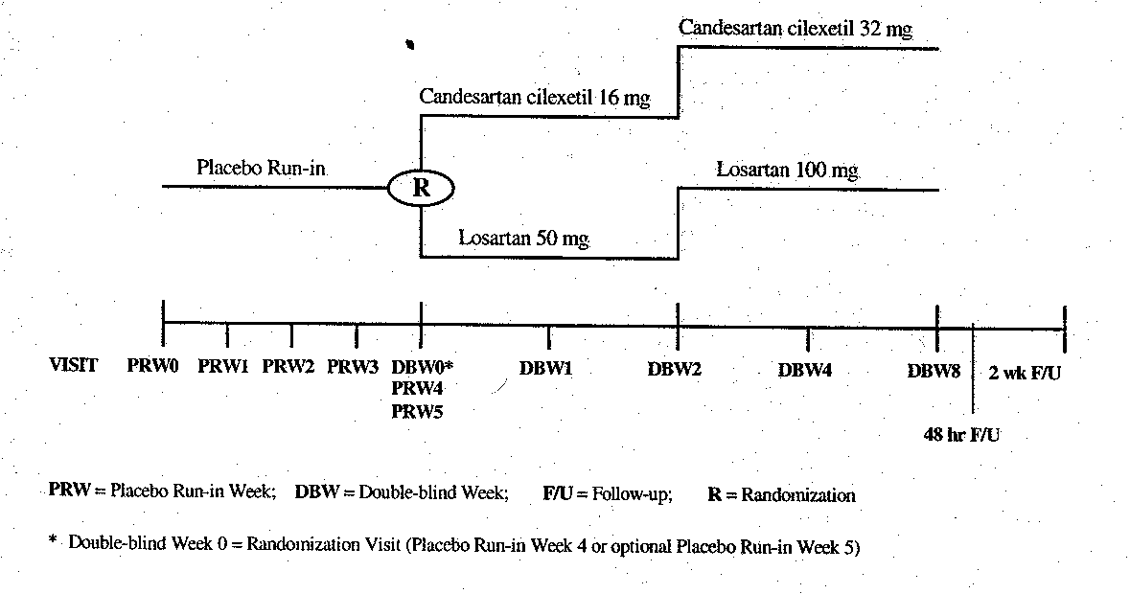
In study 230, 611 adult patients with Sitting DBP between 95 and 114 mm Hg were randomized. The baseline characteristics of these patients were:
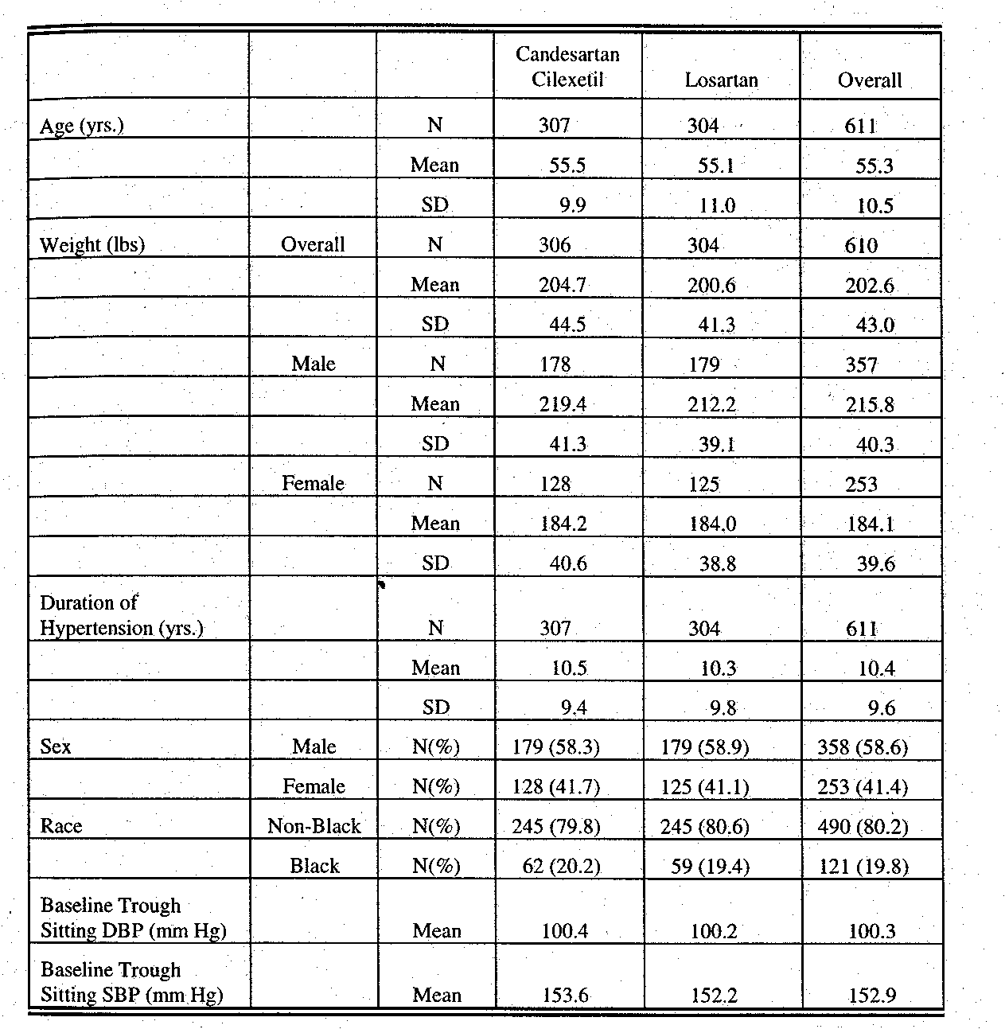

The disposition of these patients was as follows:
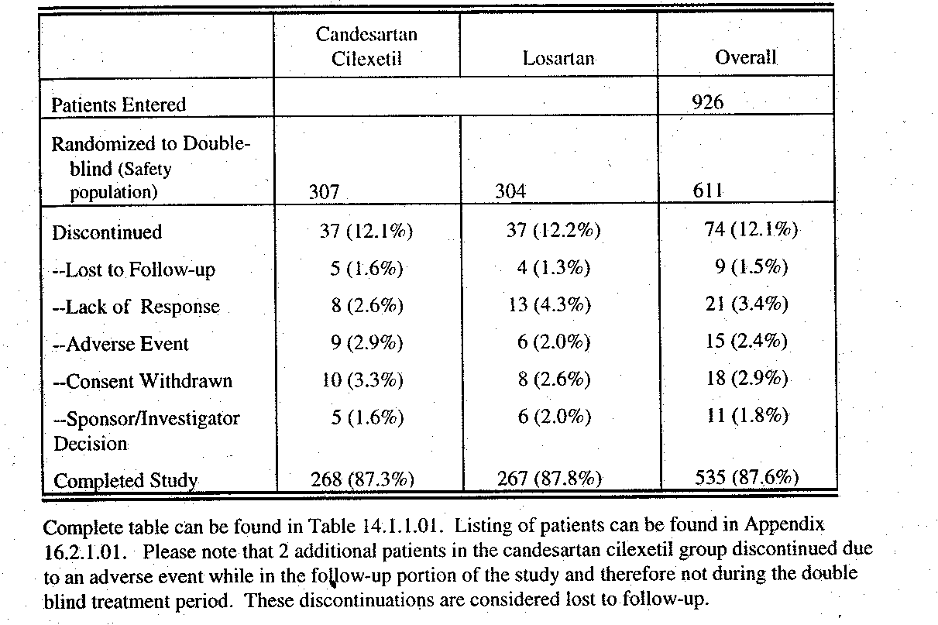
The primary endpoint was the change from baseline to week 8 for trough Sitting DBP. The primary analysis was to be the ITT/LOCF population, and these results data were:
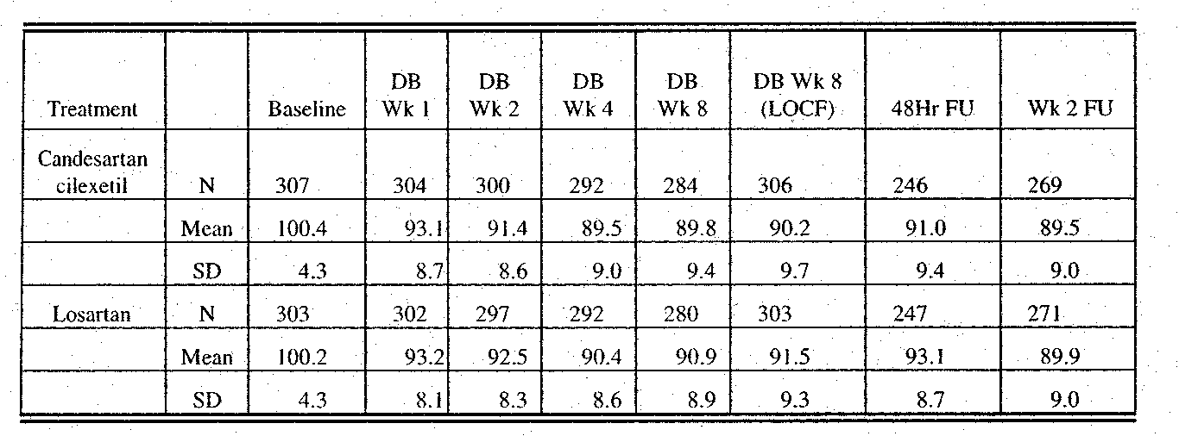

Statistical analysis of the primary endpoint as well as peak results and SBP results was:
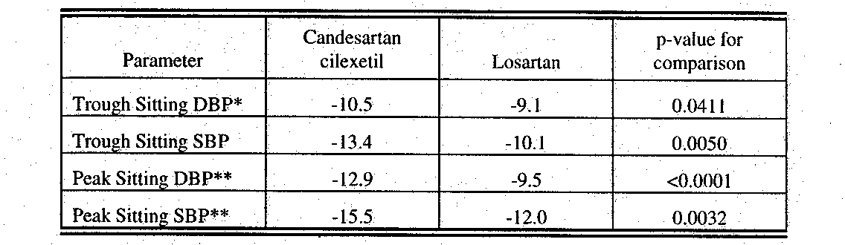

Trough Sitting SBP results showed a similar early (i.e. by two weeks at the lower starting doses) antihypertensive effect as that noted for Sitting DBP.

Subgroup analyses were presented in the following chart:
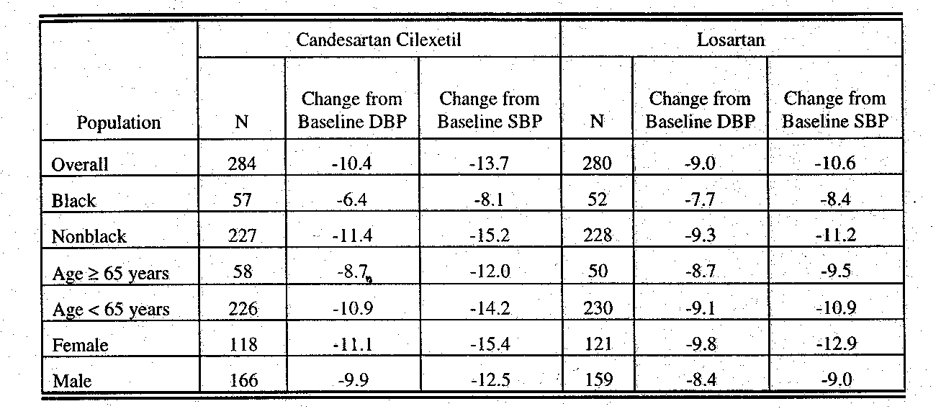

No deaths occurred in the study. 9 patients on Candesartan and 6 on losartan withdrew due to an adverse event, however only 4 events were considered serious; 2 in the Candesartan group and 2 in the losartan arm. These events were: paroxysmal supraventricular tachycardia, cerebrovascular disorder, AF and asthma respectively.
In study 231, 654 adult patients with Sitting DBP between 95 and 114 mm Hg were randomized as in study 230.
The demographic features of these patients were:
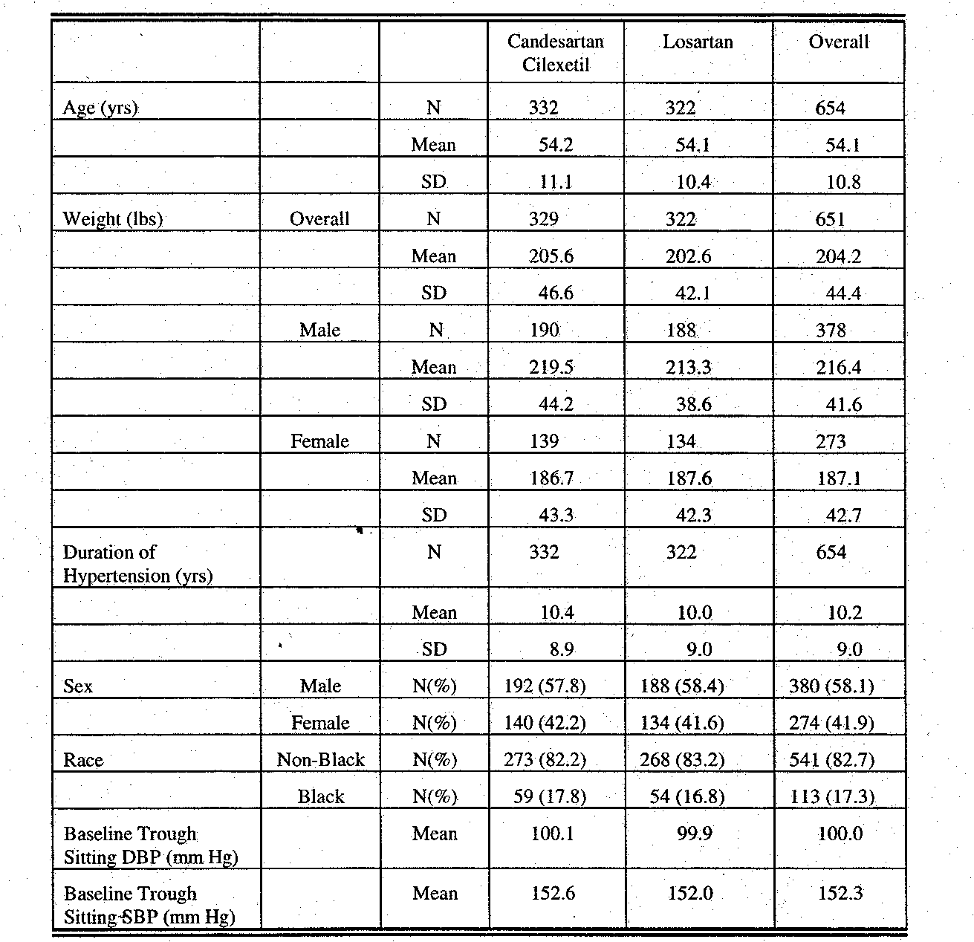

Disposition of these patients was:
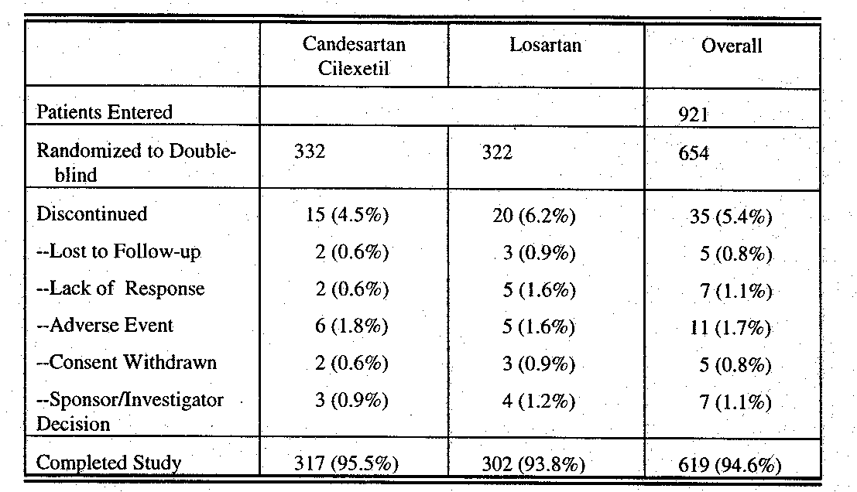
As with study 230, the data for Sitting DBP over the course of the study was:
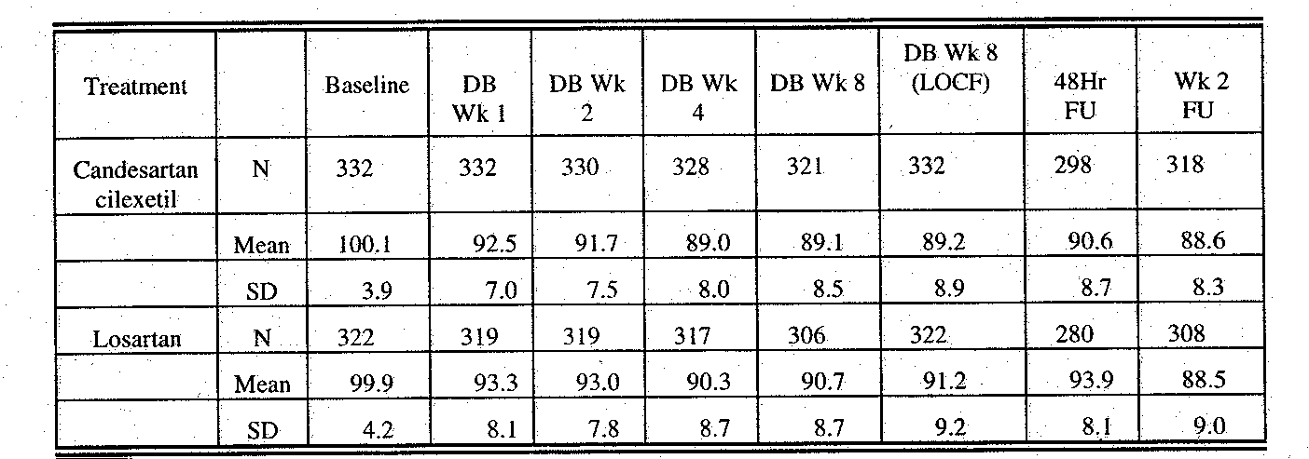

Statistical analyses of change from baseline to week 8 for the ITT/LOCF population for trough and peak Sitting DBP and SBP were:
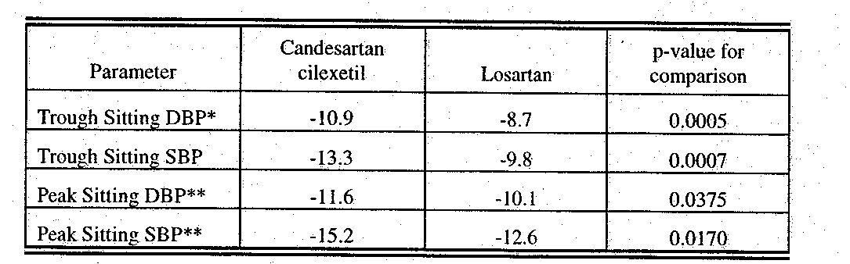

As in study 230, trough Sitting SBP change from baseline was maximal by 2 weeks for both treatments.
Subgroup analyses were presented as follows:
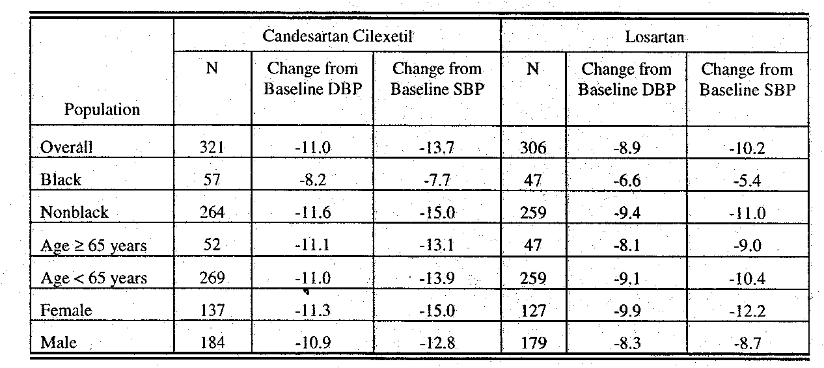

Concerning safety no deaths occurred. There were 4 serious adverse events reported; 3 in the Candesartan group (cardiac failure, myocardial infarction and accident and/or injury), and 1 in the losartan group (colitis). 11 patients withdrew for adverse reactions; 6 in the Candesartan group and 5 in the losartan arm.
Discussion
Since these comparative studies involve comparisons of specific doses, some background from the original Candesartan NDA may be helpful.

In the review of that NDA, the FDA statistician, Dr. Kooros Mahjoob, did a meta-analysis of all parallel dose response, placebo controlled studies. The NDA review can be consulted for details, but 2367 patients from 9 studies were included in the analysis. Placebo (n=630), CC (Candesartan) 2mg (n=133), CC 4 mg (n=352), CC 8 mg (n=695), CC 12 mg (n=154), CC 16 mg (347) and CC 32 mg (n=54) were included. Various analyses were done including raw means comparisons of DBP and SBP as well E-max models. The least square means result for Sitting DBP was:
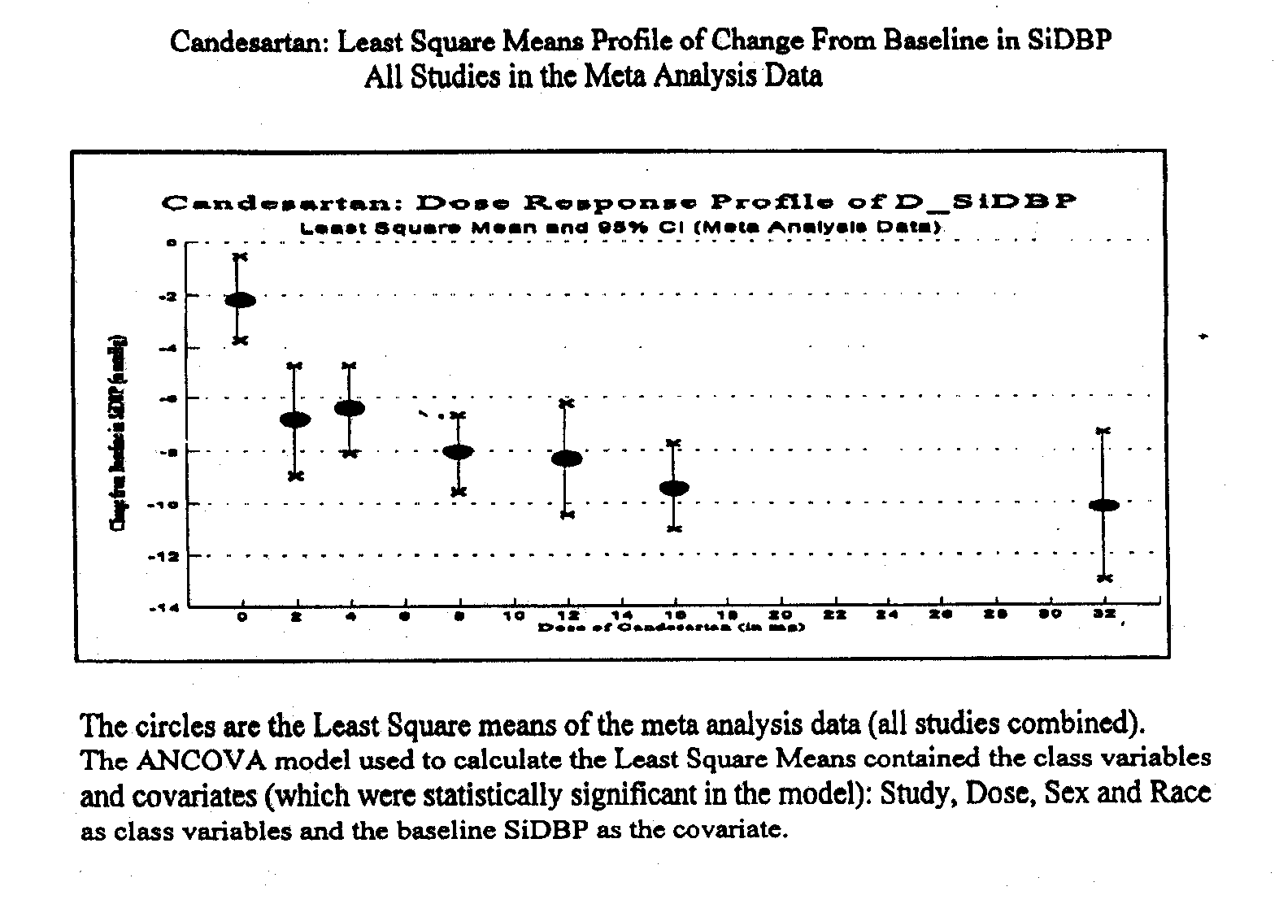

The curves using other models and the raw means for both DBP and SBP were similar. The reviewers concluded that the CC dose response appeared to be maximal at 16 mg. Too few patients had been studied at 32 mg to rule out some additional antihypertensive effect at that dose.

In the original NDA 20386 for losartan, the medical officer, Dr. Charles Ganley, reviewed the major efficacy study (study 011) that explored a once-daily dose range from 10 mg to 150 mg with both placebo and enalapril 20 mg control arms. The design of the study was as follows:
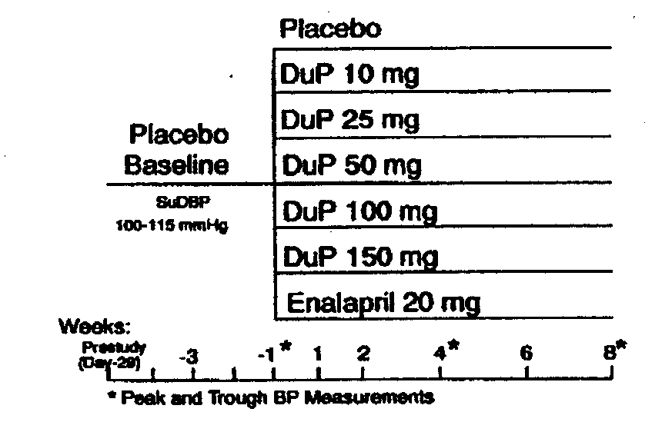
DuP was losartan. The results were displayed in the review:
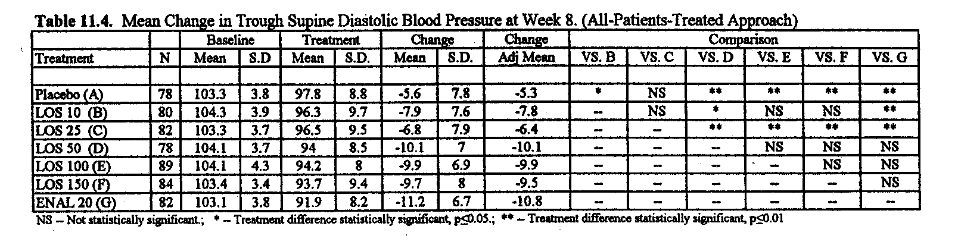

While losartan 25 mg once-daily was significantly effective, 50 mg once-daily gave the maximum antihypertensive effect with no additional benefit noted for either the 100 or 150 mg losartan dose.

Study 065 was a placebo controlled, 12 week study of losartan 25 mg once-daily, 50 mg once-daily and 25 mg BID in 428 randomized patients with mild to moderate hypertension. Results were:
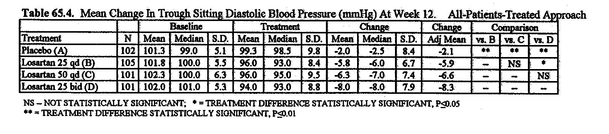
The comparison between losartan 50 mg once-daily and 25 mg BID was a secondary endpoint. The difference between the regimes was not significant, but there was a numerical difference favoring the BID regimen.

For Candesartan, no study of the drug given in divided doses was provided. The approved labeling states: “With once-daily dosing, blood pressure effect was maintained over 24 hours, with trough-to-peak ratios of blood pressure effect generally over 80%.”
AstraZeneca did provide a study comparing the antihypertensive effects of CC 8 and 16 mg to losartan 50 mg and placebo, each given once-daily. Results of that study per the sponsor follows:
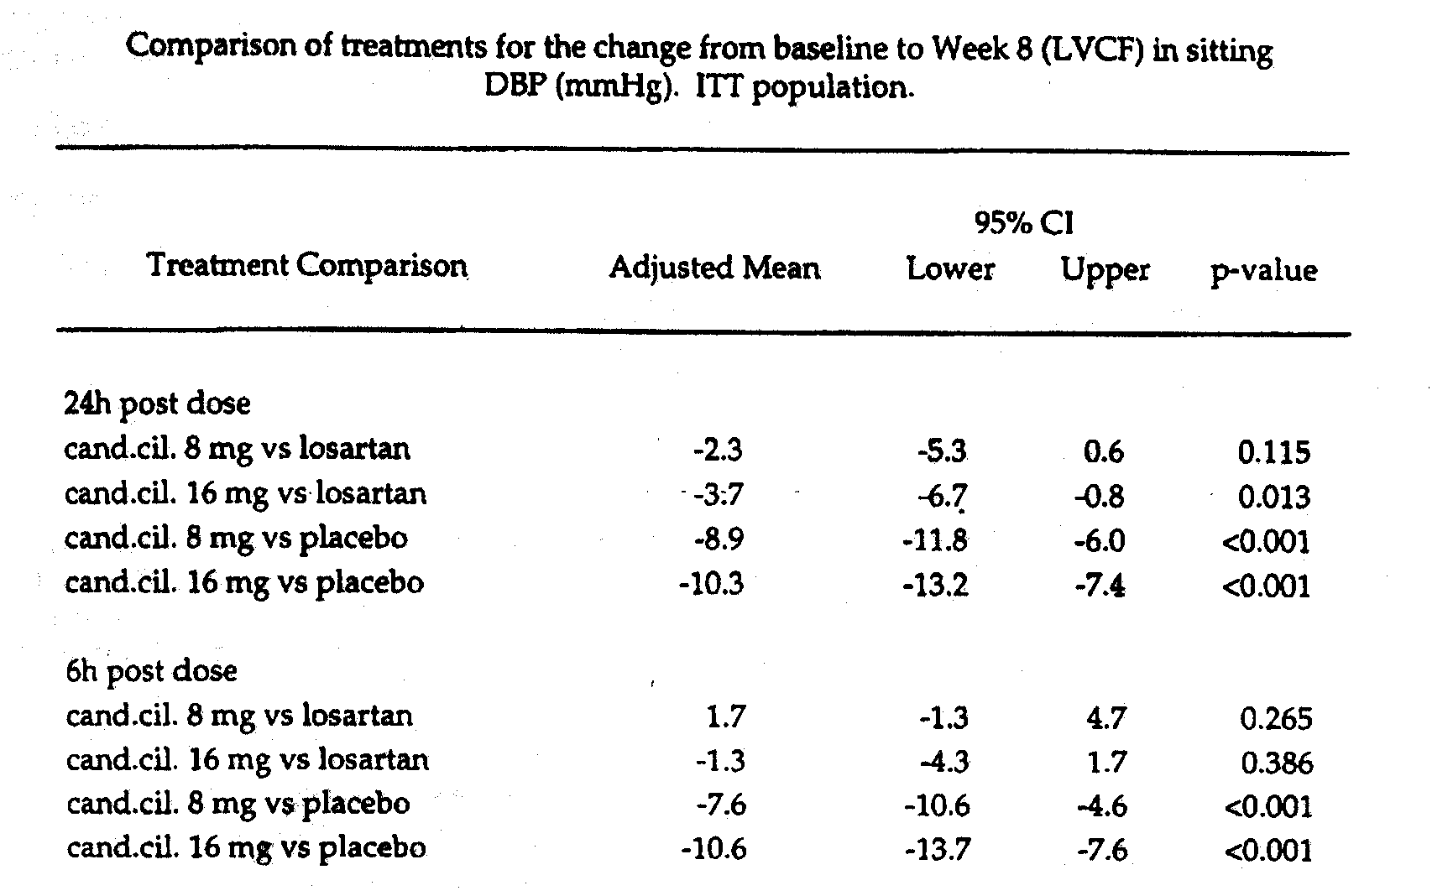
It would appear from the chart above that the 50 mg once-daily dose of losartan is less effective than 16 mg of Candesartan, but not distinguishable from 8 mg of Candesartan.

The currently approved Candesartan labeling for Dosage and Administration states:
“Dosage must be individualized. Blood pressure response is dose related over the range of 2 to 32 mg. The usual starting dose of ATACAND is 16 mg once-daily when it is used as monotherapy in patients who are not volume depleted. Atacand can be administerd once or twice daily with total daily doses ranging from 8 mg to 32 mg. Larger doses do not appear to have a greater effect, and there is relatively little experience with such doses. Most of the antihypertensive effect is present within 2 weeks, and maximal blood pressure reduction is generally obtained within 4 to 6 weeks of treatment with ATACAND.”
For losartan that section states:
“The usual starting dose of COZAAR is 50 mg once-daily, with 25 mg used in patients with possible depletion of intravascular volume (e.g. patients treated with diuretics) (see WARNINGS, hypotension-Volume Depleted Patients) and patients with hepatic impairment (see PRECAUTIONS, General). COZAAR can be administered once or twice daily with total daily doses ranging from 25 mg to 100 mg.
If the antihypetensive effect measured at trough using once-a-day dosing is inadequate, a twice-a-day or an increase in dose may give a more satisfactory response.”

In the CANDLE study, treatment was initiated at 16 mg of CC and 50 mg of losartan once-daily for 2 weeks, followed by an elective titration to 32 mg or 100 mg once-daily respectively. In the CLAIM studies, treatment was initiated at 16 mg and 50 mg once-daily for CC and losartan respectively with a forced titration at 2 weeks to 32 mg of CC and 100 mg of losartan once-daily.

The following chart details the change in trough Sitting DBP from baseline to week 2 and then from week 2 through week 8 (LOCF) for each treatment in each study.
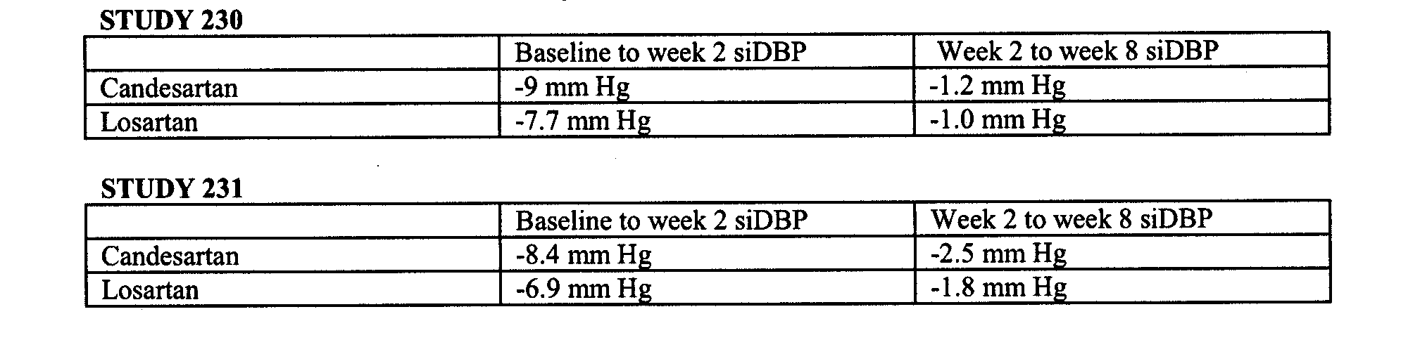

The sponsor observed that the week 2 to week 8 changes were greatest in those not responding to the initial dose, and provided the following subgroup results for study 230 and 231.
Study 230:
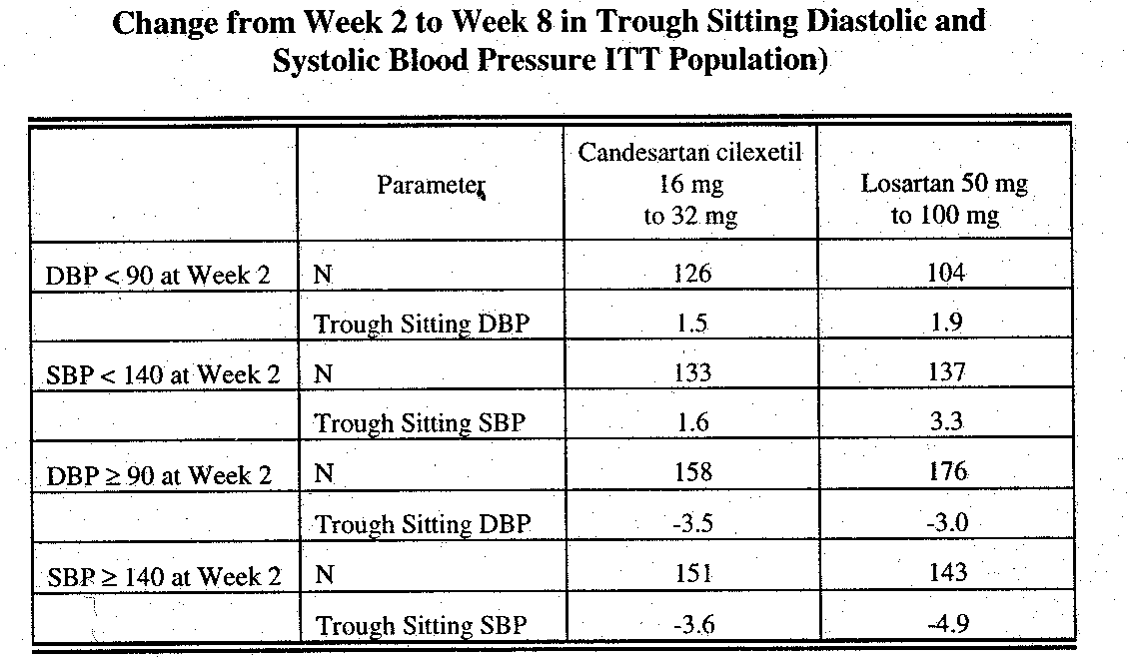

Study 231:
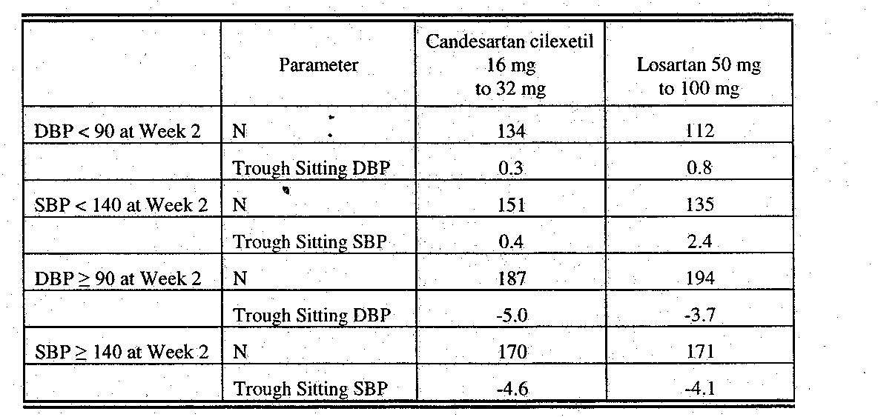

In the CANDLE study where elective titration after 2 weeks was permitted, approximately 54% of the Candesartan patients and 58% of the losartan patients were up-titrated.
For the not up-titrated group, the trough Sitting DBP change from baseline at 2 weeks for the Candesartan group was 11.4 mmHg, and 1.2 mmHg from 2 weeks through 8 weeks (LOCF). Those results for the losartan patients were 9.4 and 1.9 mmHg.
For the up-titrated group, the Candesartan result at 2 weeks was 6.6 mmHg, and for 2 through 8 weeks (LOCF) 3.1 mmHg. For losartan the results were 5.2 and 2.0 mmHg.

Since there were no Candesartan 16 mg and losartan 50 mg arms, it is not possible to conclude that the decrease in blood pressure from week 2 to week 8 seen in “nonresponders” compared to “responders”was due to the higher dose of each drug, rather than a slower response at the lower doses (or placebo, had that been included). Without Candesartan 16 mg and losartan 50 mg treatments continued for eight weeks, it is not possible to conclude that the higher doses were necessary to reach the blood pressures found at 8 weeks. The results do not support the conclusion that the significant differences found were due to the top labeled doses, rather than the starting doses.

The results of the CLAIM studies as well as the CANDLE study do support the conclusion that 16 mg CC once-daily provides more antihypertensive effect than losartan 50 mg given once-daily. Higher doses did not provide more antihypertensive effect than the usual starting doses in the ITT analyses. That finding is consistent with the data from the original NDAs. Suggestions that the 32 mg dose once-daily of Candesartan might be superior to 100 mg of losartan once-daily in patients not adequately responding to the usual starting doses would need to be studied in a properly designed trial. Since the CANDLE study demonstrated that once-daily 16 mg of Candesartan and 50 mg of losartan provided similar percentages of adequately controlled patients after 2 weeks (46% and 42% respectively), the clinical superiority of one drug over the other was not evident.
Moreover, the twice daily losartan regimen as well as the low end of the approved dose ranges of both drugs have not been evaluated. These studies, therefore, do not support the superiority of one drug versus the other. However, evidence of one point to point specific regimen superiority of Candesartan to losartan is provided, and on the basis of these studies AstraZeneca requests that the following information be added to the Clinical Trials section of the labeling:
“Two identically designed, concurrently conducted, 8 week, multicenter, double-blind, randomized, forced-titration studies were performed to compare the antihypertensive efficacy of candesartan cilexetil and losartan at their once-daily maximum doses. Candesartan cilexetil intiated at 16 mg once-daily and force-titrated at 2 weeks to 32 mg once-daily was statistically significantly more effective than losartan 50 mg once-daily forced-titrated at 2 weeks to 100 mg once-daily in reducing systolic and diastolic blood pressure at 8 weeks. In these studies, both agents were well-tolerated." This statement is literally true, and supported by two adequate and well-controlled studies. My concern is that overall drug clinical superiority may be inferred from the statement. If comparative effectiveness information were to be provided in the label, the average sitting DBP and sitting SBP differences should be provided so the clinician has some idea of the magnitude of difference found. While it is not generally the responsibility of one manufacturer to provide full information about another manufacturer’s competing drug, when a comparative effectiveness claim is made balanced information should be provided. Suggestions for such are:
- Given the approved dose ranges and regimens for Candesartan and losartan, no data are available to suggest that patients with hypertension would be more satisfactorily treated with one drug or the other.
- Losartan may provide more antihypertensive effect by giving the 50 mg usual starting dose BID, rather than QD. That regimen was not studied in the comparative studies provided. No data comparing BID and QD regimens of Candesartan have been provided.
- In these studies, the antihypertensive effects of both Candesartan and losartan occurred in the first 2 weeks of therapy on 16 mg and 50 mg once-daily respectively. Up-titrating to 32 mg and 100 mg once-daily respectively did not provide additional benefit.

HEPATICALLY IMPAIRED PATIENTS

The sponsor included study SH-AHC-0009, Pharmacokinetics of Candesartan Cilexetil in Patients with Moderate to Severe Impairment of Liver Function in this submission. The original NDA contained study EC023 that evaluated the PK of Candesartan at 12 mg once-daily for 7 days in 25 subjects with and without impaired hepatic function. Impaired hepatic function was categorized as mild to moderate liver disease with fatty liver, hepatitis patients but not cirrhotics considered for entrance. Liver disease was determined by liver enzyme, antipyrine clearance, sonogram or biopsy. 13 hepatically impaired patients were entered, 1 withdrew. 12 normal subjects entered.

The PK results for day 1 were:
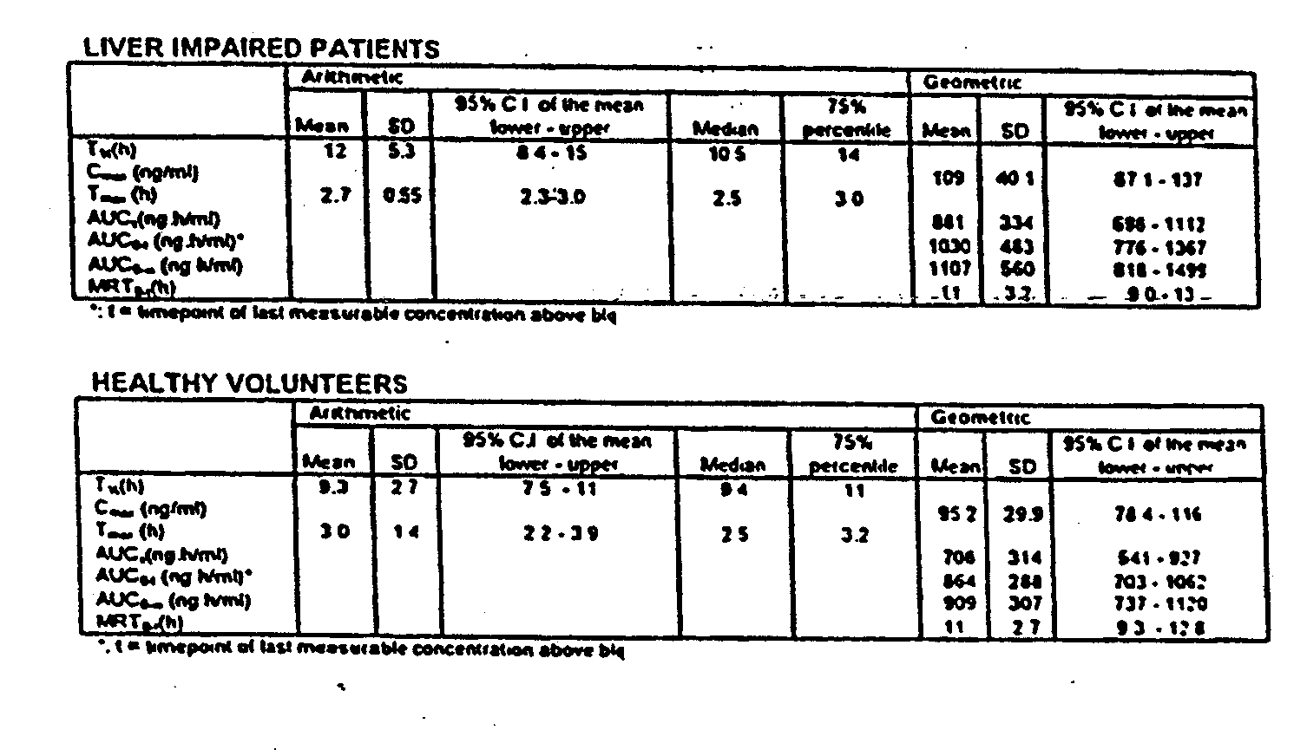
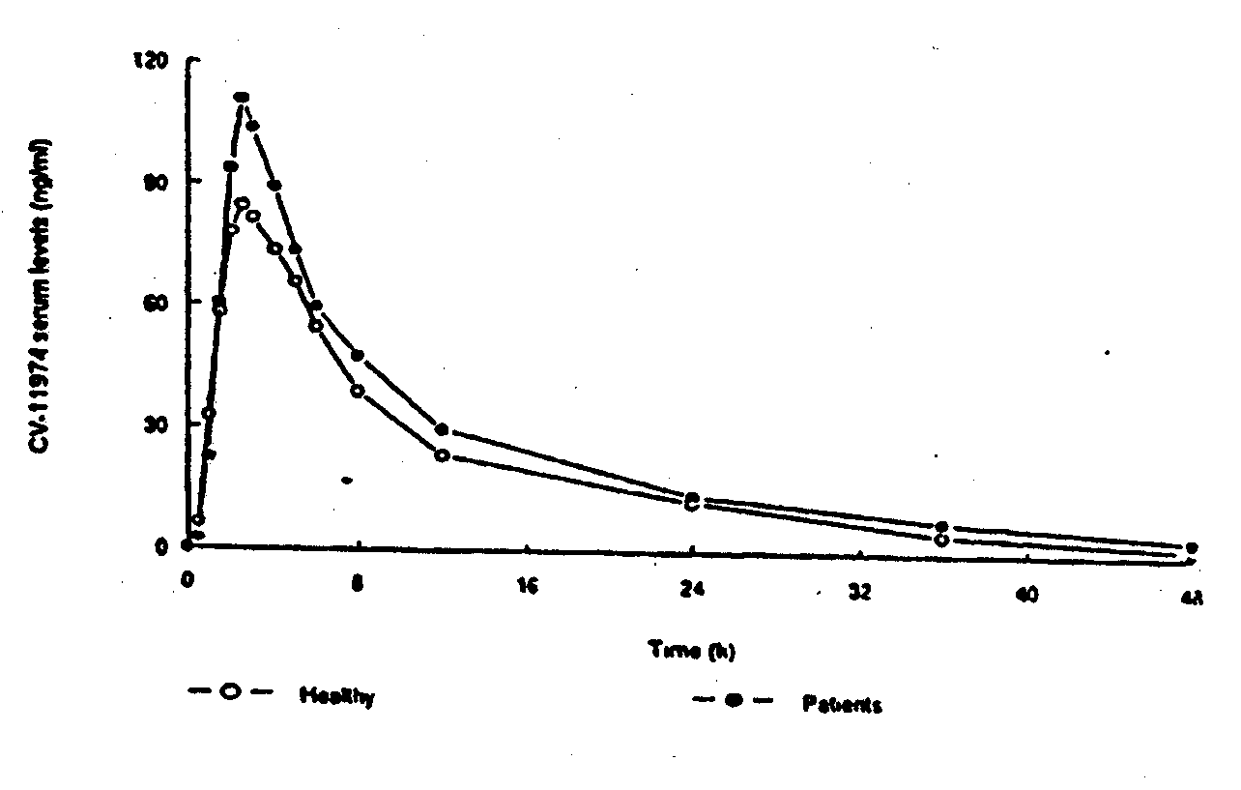

Results for day 7 were:
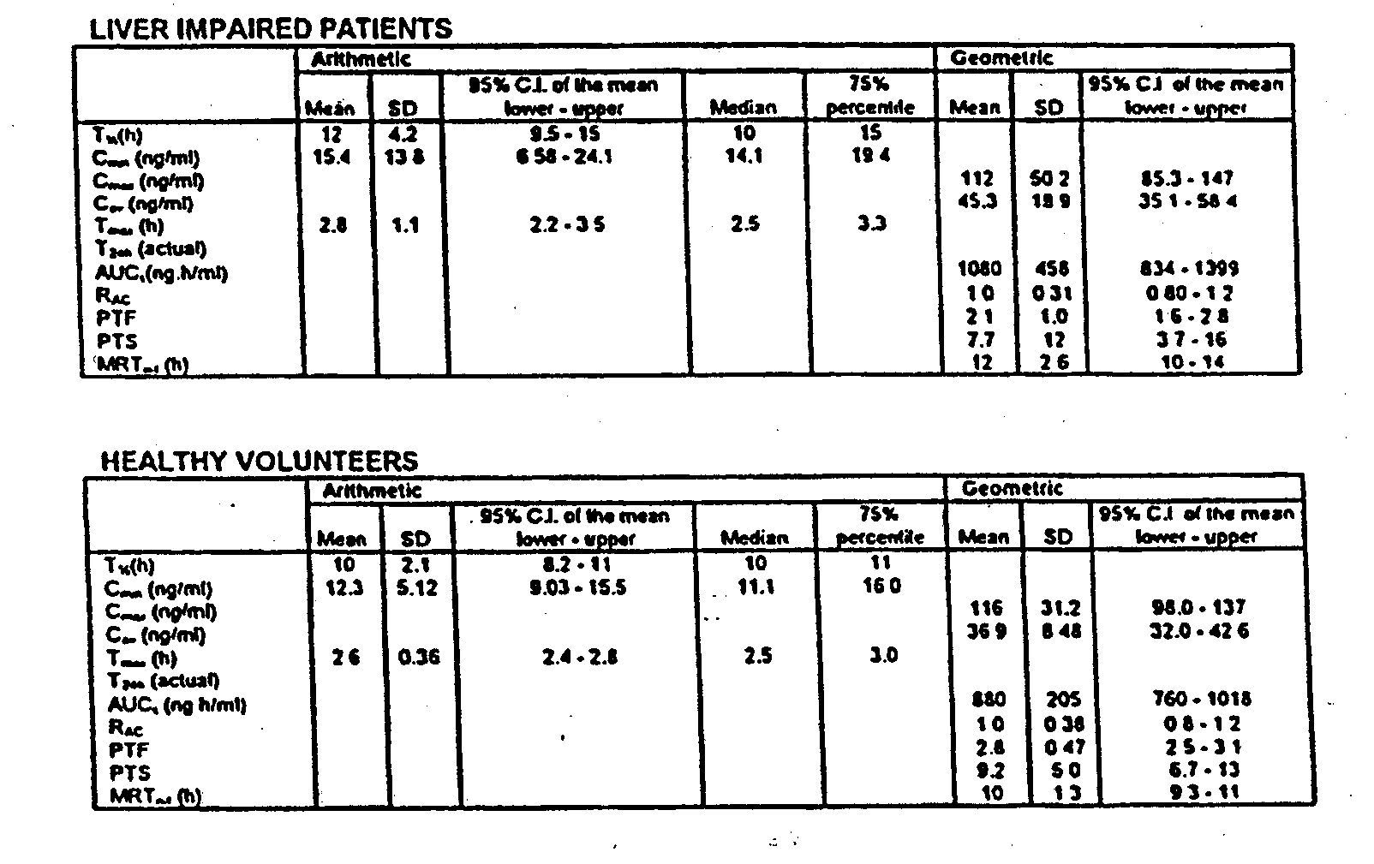

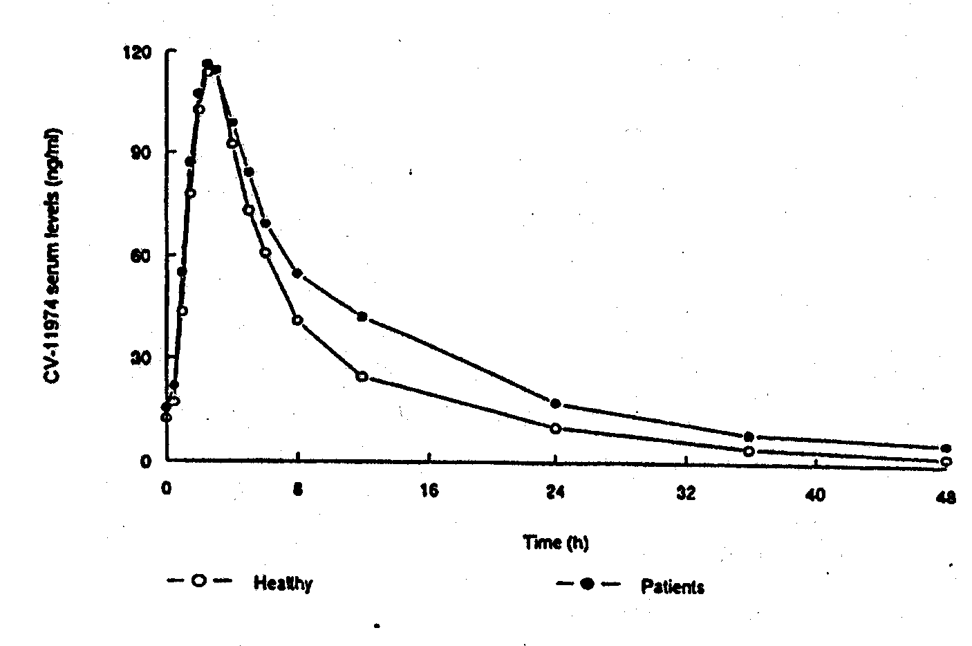

Unbound fraction results for days 1 and 7 were:
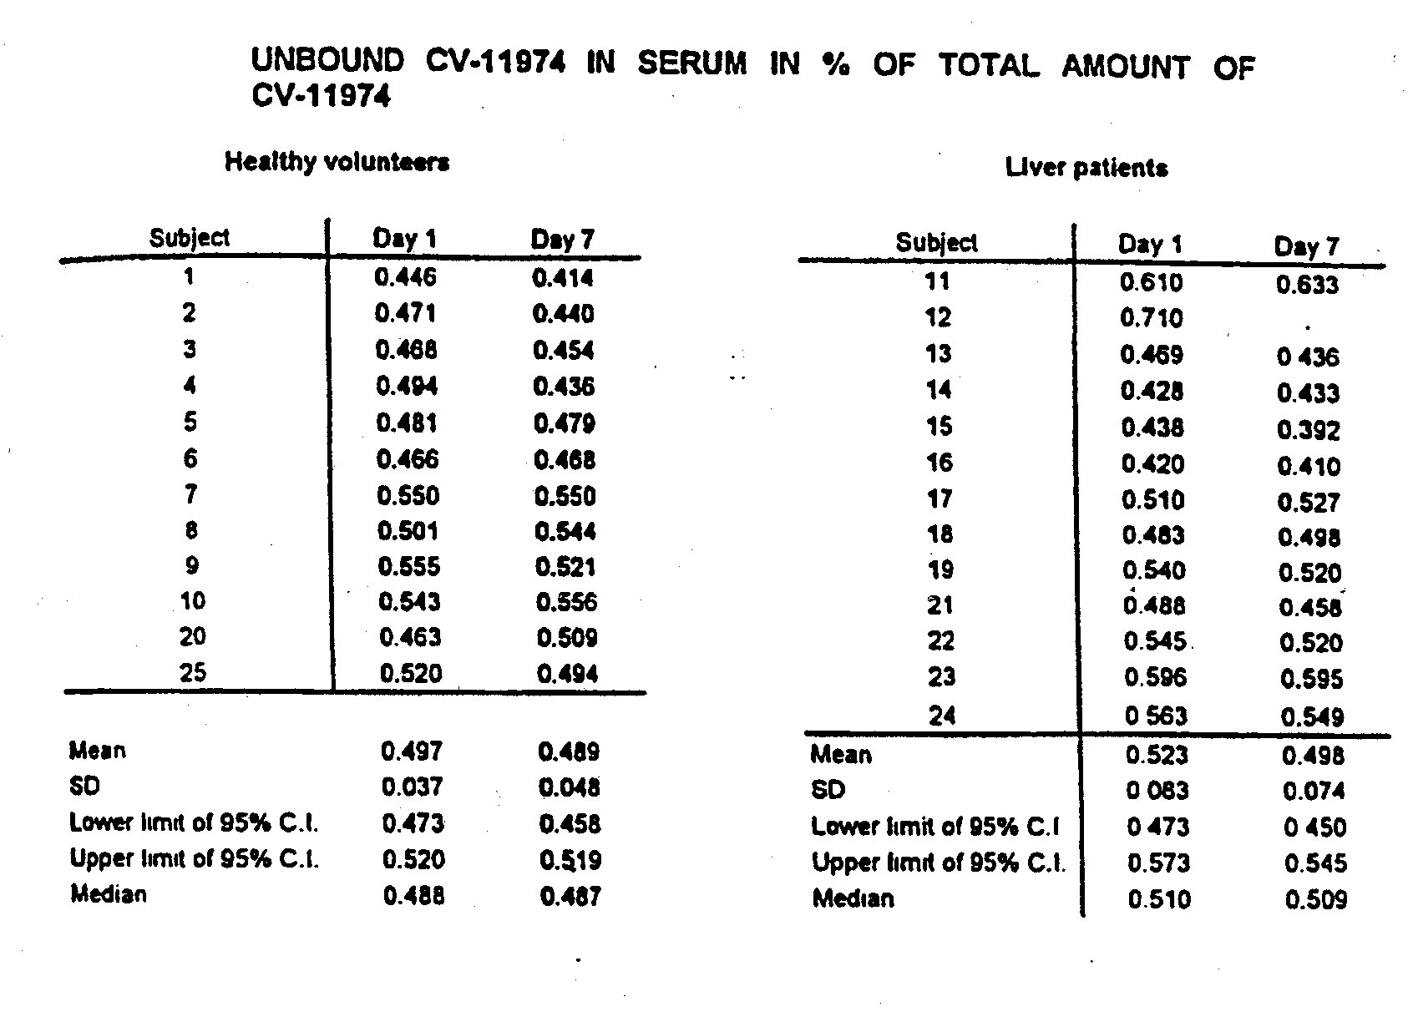
None of the numerical differences were statistically significant.
On the basis of this study, the currently approved labeling states that “no differences in the pharmacokinetics of candesartan were observed in patients with mild to moderate chronic liver disease.”

The newly submitted study, AHC-0009, was completed in April 1997. It was a single center, open PK study of single 16 mg dose Candesartan in 12 patients with moderate to severe liver disease compared to 12 healthy volunteers matched by age, gender and weight.
The design of the study was:
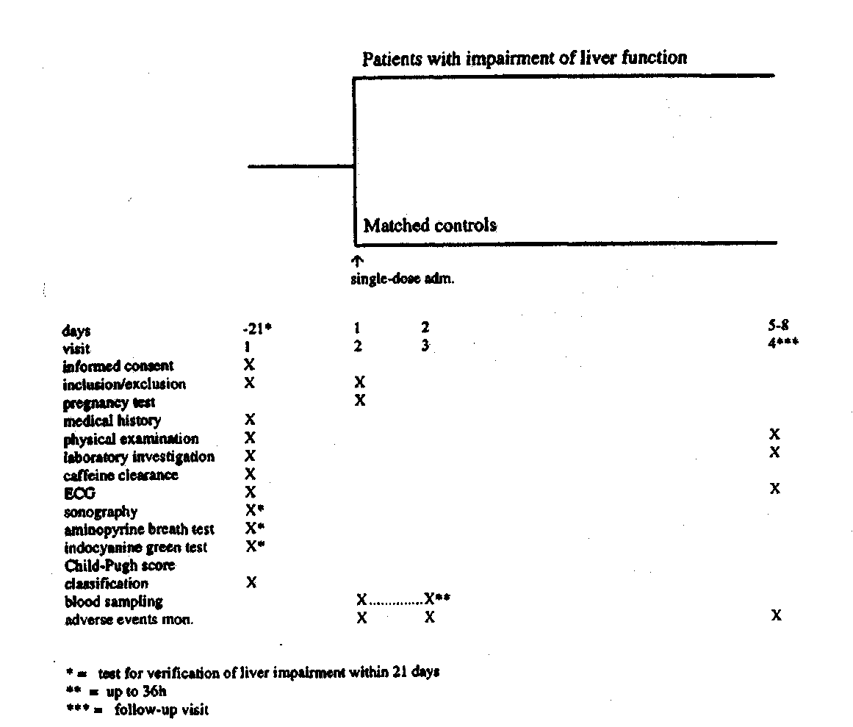

Impaired liver function was determined by using the Child-Pugh methodology as shown:
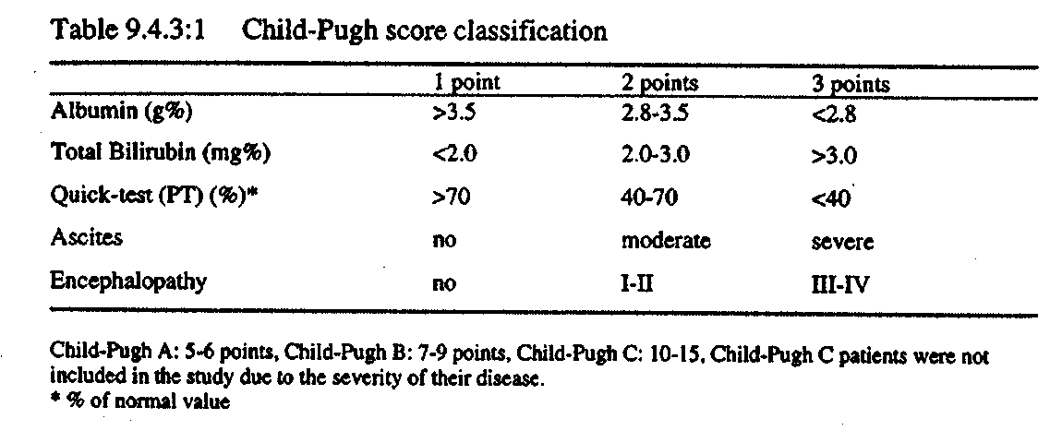
6 Child-Pugh A and 6 Child-Pugh B patients were entered. For analysis purposes these were all included in the primary pre-specified analysis. While not called for by the protocol, analyses of each group separately versus the matched controls were done.

The major PK analytic results were:
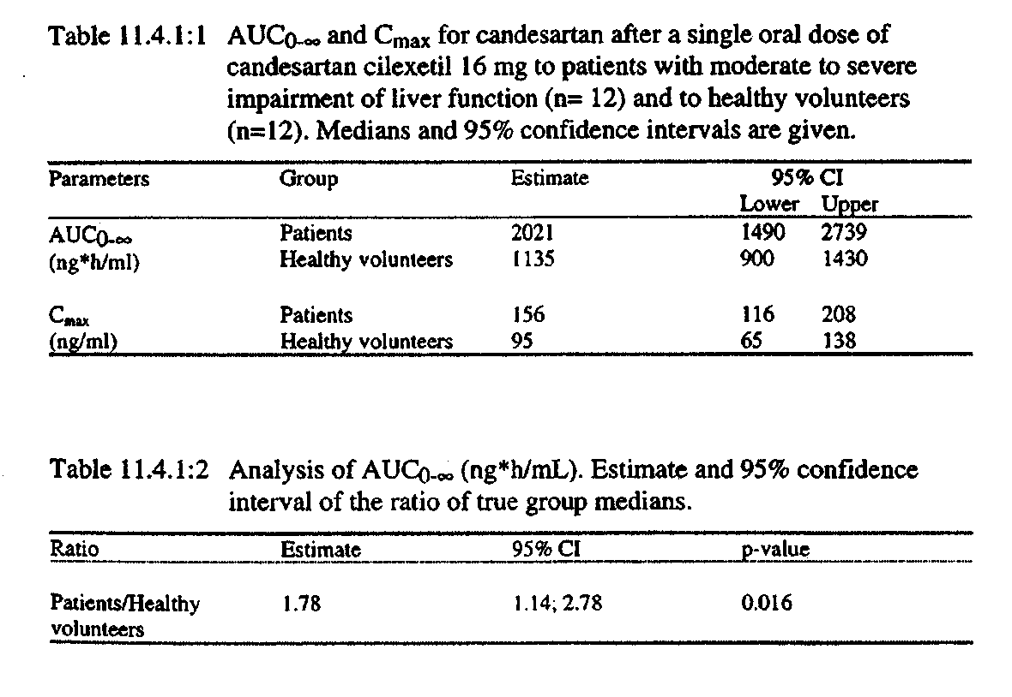
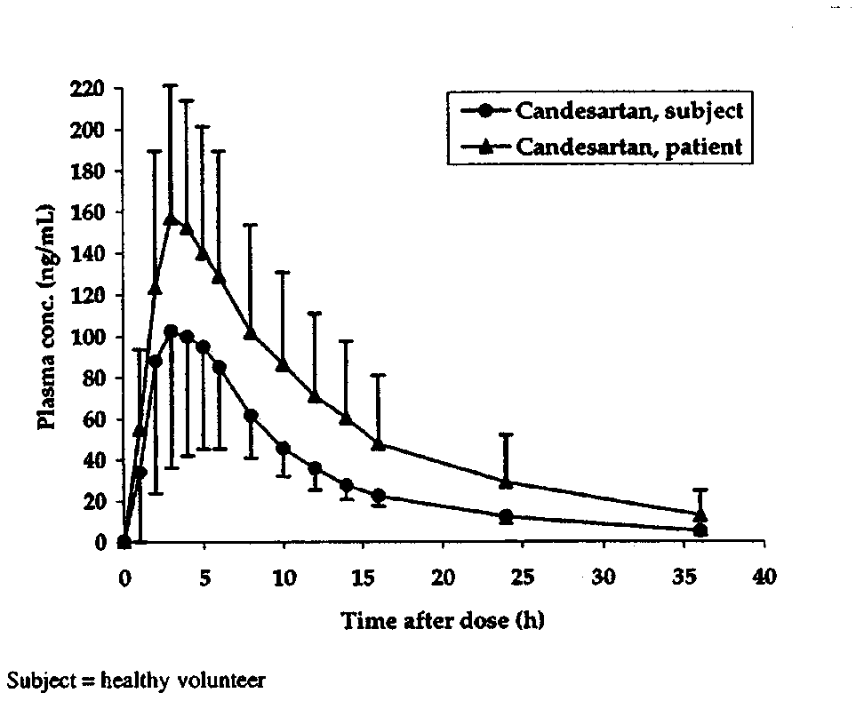

Subgroup analyses of Child-Pugh A and B versus control were:
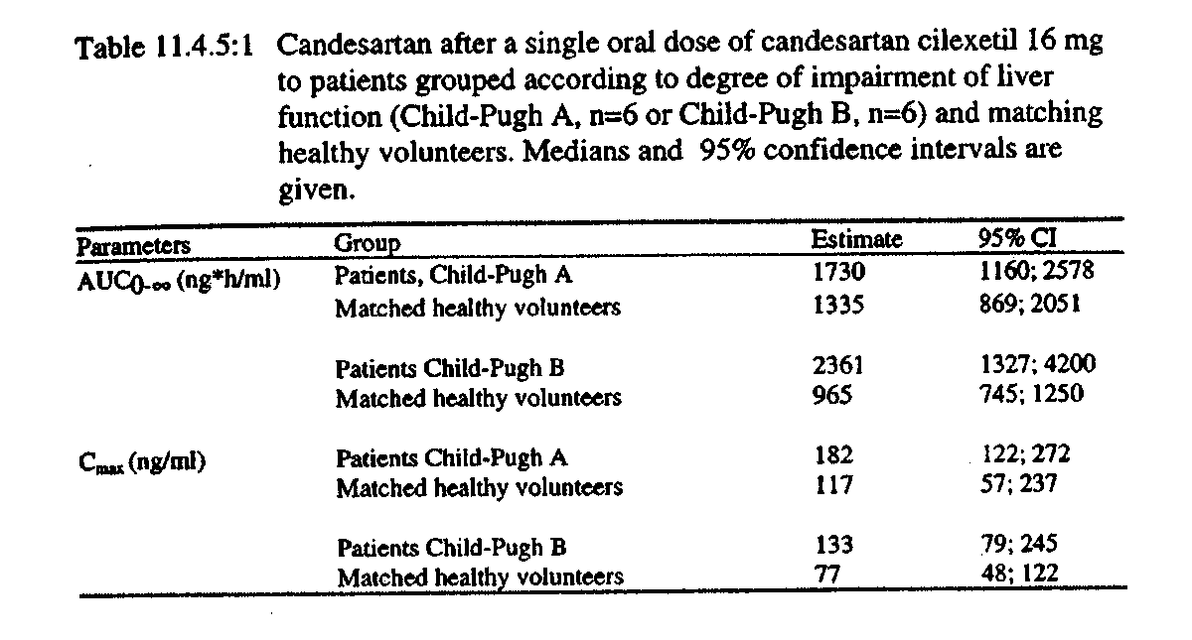

Concerning safety, no deaths or withdrawal for adverse events occurred. Two serious adverse events occurred in the hepatically impaired patients. One patient had an accidental injury of the shoulder, and another developed erysipelas. Both were considered unrelated to the drug. Adverse events were reported as follows:
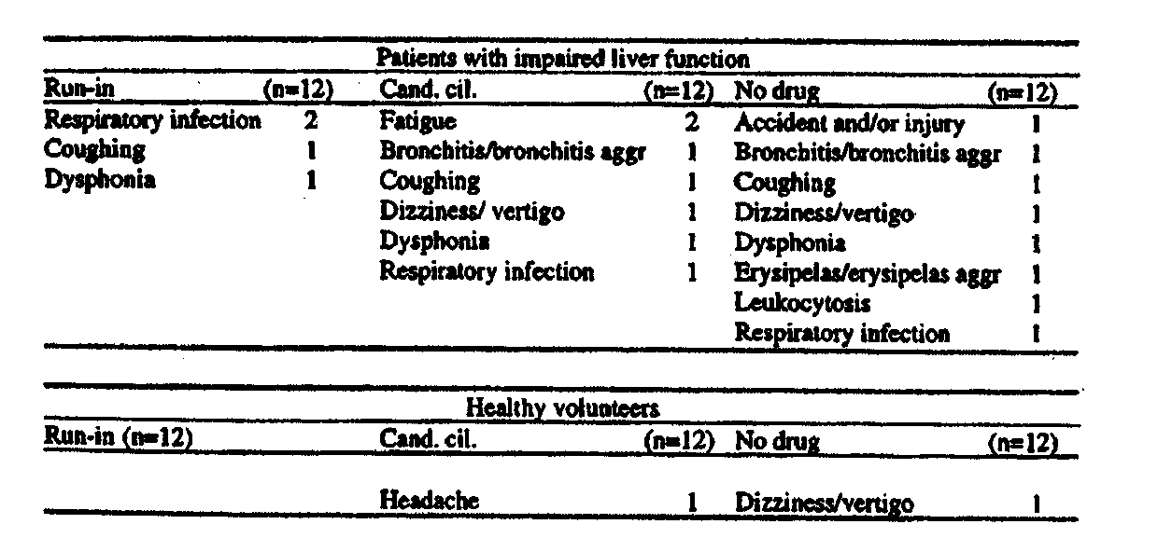

The sponsor also provided a listing of postmarketing reports involving hepatic disease. There were 10 reports in 9 patients:
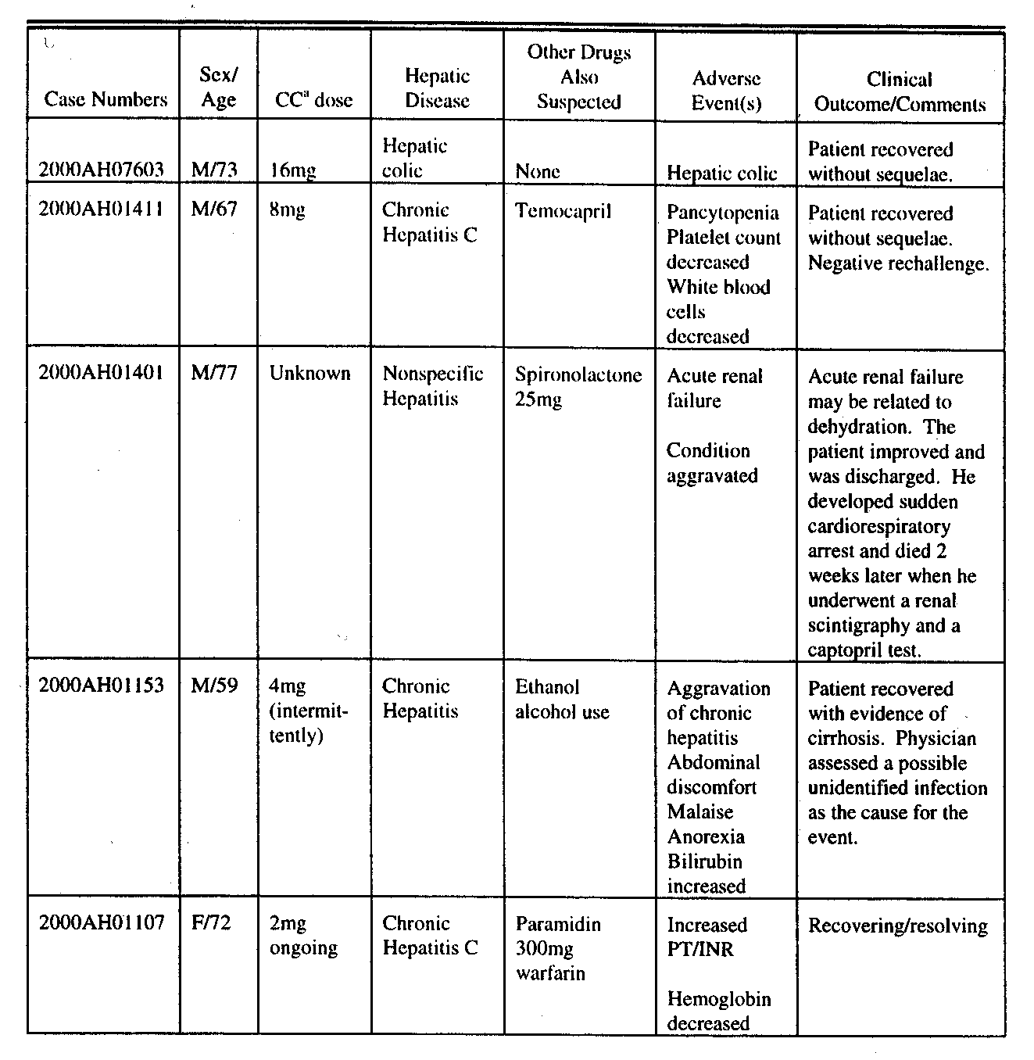
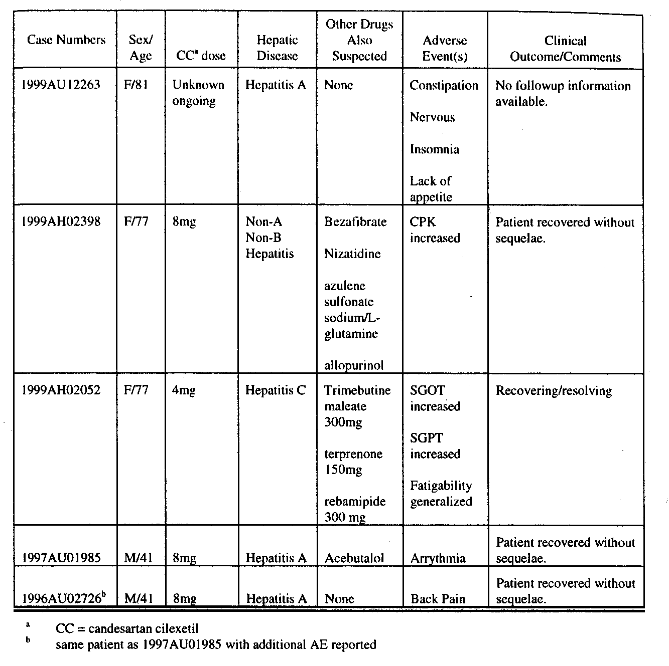

Although the hepatic events do not appear to have been caused by Candesartan, it should be noted that the dose of Candesartan (where known) was less than the recommended starting dose.

Discussion
The results of this study do suggest that, when a single oral 16 mg dose of Candesartan is given, patients with moderate hepatic impairment (Child-Pugh A and B) have increased Cmax and AUC compared to control. It is unclear whether patients with this degree of hepatic impairment need special dosing limitations, and very severely ill patients were not studied. The sponsor has requested a labeling change to delete reference to the study EC023and include the results of this study. They also request a Precaution be added and a change in dosing instructions to consider a lower staring dose in patients with “moderate hepatic impairment.” While adding the results of AHC-0009 to those of EC023 would be reasonable, terms such as moderate and severe may not be clear to the clinician. The specific study inclusion criteria might be provided, i.e. Child-Pugh classification. For those patients with Child-Pugh B and C hepatic impairment. The suggestion that a dose lower than 16 mg be used as the starting dose in patients with moderate and severe hepatic impairment can be included in the labeling.

OVERDOSAGE
The currently approved Candesartan label describes one overdose case, a 43 year old female who intentionally took 160 mg of Candesartan along with other drugs and recovered after gastric lavage and observation. Since the original approval, 4 additional overdose cases were reported as summarized in the following table:
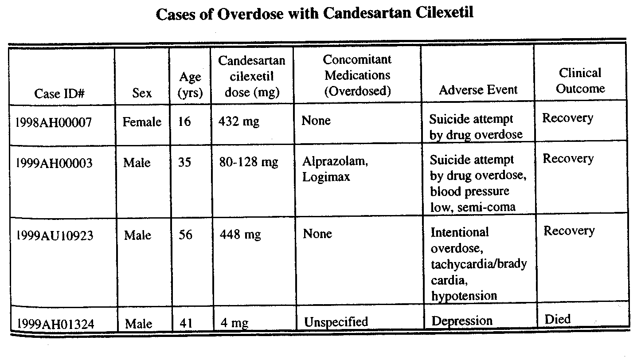

The 41 year old male who died had been taking 4 mg of Candesartan and was under treatment for depression and epilepsy. The patient was suicidal and died on 7/4/99 from an overdose of medication and alcohol, but it is unknown if Candesartan was being used at all at the time of the overdose.
The 16 year old female who took 432 mg of Candesartan recovered overnight without treatment or observation. Hypotension was reported in the two other cases. Based on these case reports the sponsor proposes to replace the description of the one overdose case currently present in the labeling with the following general information based on all available cases:
“The most likely manifestaton of overdosage would be hypotension, dizziness, and tachycardia; bradycardia could occur from parasympathetic (vagal) stimulation. If symptomatic hypotension should occur, supportive treatment should be initiated.”
The sponsor notes that these changes are consistent with the more recently approved Candesatan-Hydrochlorothiazide drug labeling. The revision retains all other approved portions of the overdose section, and the new wording is the same as has been approved for the Candesartan portion of the combination drug labeling.

CONCLUSIONS AND RECOMMENDATIONS
The CANDLE and CLAIM studies do demonstrate the Candesartan 16 mg once daily provides on average more antihypertensive effect (approximately 2 mmHG for sitting DBP) compared to 50 mg of losartan once daily. The sitting DBP measurement has been accepted as a surrogate for clinical benefit to approve new antihypertensive drugs. While a 2 mmHg difference from control would be sufficient for a demonstration of effectiveness, the translation of that difference into numbers of lives saved, strokes or myocardial infarctions prevented, which are the clinical parameters of importance, is not established. The usual comparator is placebo. Here the comparator is another active sartan. In either case the studies reconfirm that Candesartan is effective as an antihypertensive. However, they do not establish clinical superiority of Candesartan to losartan. Comparative effectiveness data of antihypertensives may be of interest to clinicians, and the Candesartan labeling can be revised to contain the results of these studies. If that is done, it should be made clear that both drugs are effective and Candesartan was not shown to be clinically superior to losartan. Clinically, either drug can be used to treat hypertension successfully, and no superior efficacy can be assumed from a 2 mmHg average difference in sitting DBP of one dose versus another. For individual antihypertensive drugs we recommend individualization of dosing, and provide a dose range to be used clinically. The same is true for comparing doses of different drugs. We do not have data on BID dosing of Candesartan and losartan, and there are data to suggest that BID losartan may give more antihypertensive effect than QD dosing. If comparative effectiveness information were to be provided in the label, the average sitting DBP and sitting SBP differences should be provided so the clinician has some idea of the magnitude of the differences found. Other suggested modifying language that might be included is:
- Given the approved dose ranges and regimens for Candesartan and losartan, no data are available to suggest that patients with hypertension would be more satisfactorily treated with one drug or the other.
- Losartan may provide more antihypertensive effect by giving the 50 mg usual starting dose BID, rather than QD. That regimen was not studied in the comparative studies provided. No data comparing BID and QD regimens of Candesartan have been provided.
- In these studies, the antihypertensive effects of both Candesartan and losartan occurred in the first 2 weeks of therapy on 16 mg and 50 mg once-daily respectively. Up-titrating to 32 mg and 100 mg once-daily respectively did not provide additional benefit.

Concerning the other proposed labeling changes, the results of the new PK study in hepatically impaired patients can be included with information on the Child-Pugh scale. The suggested dose modification in hepatically impaired patients can be included. The revised overdose section is acceptable.

CC: Dr. Throckmorton
Dr. Stockbridge
Dr. Nhi Nguyen
Dr. Hung
Mr. Fromm

